UNITED STATES
SECURITIES AND EXCHANGE COMMISSION
WASHINGTON, D.C. 20549

FORM 8-K

CURRENT REPORT
Pursuant to Section 13 or 15(d) of the Securities Exchange Act of 1934
Date of Report (Date of earliest event reported): July 30, 2026

FTI Consulting, Inc.
(Exact name of Registrant as Specified in Its Charter)

Maryland |  |  | 001-14875 | 52-1261113
(State or Other Jurisdiction  of Incorporation) |  |  | (Commission File Number) | (IRS Employer  Identification No.)
555 12th Street NW
Washington, District of Columbia |  |  |  | 20004
(Address of Principal Executive Offices) |  |  |  | (Zip Code)

Registrant’s Telephone Number, Including Area Code: 202 312-9100

Not Applicable
(Former Name or Former Address, if Changed Since Last Report)

Check the appropriate box below if the Form 8-K filing is intended to simultaneously satisfy the filing obligation of the registrant under any of the following provisions:
☐Written communications pursuant to Rule 425 under the Securities Act (17 CFR 230.425)
☐Soliciting material pursuant to Rule 14a-12 under the Exchange Act (17 CFR 240.14a-12)
☐Pre-commencement communications pursuant to Rule 14d-2(b) under the Exchange Act (17 CFR 240.14d-2(b))
☐Pre-commencement communications pursuant to Rule 13e-4(c) under the Exchange Act (17 CFR 240.13e-4(c))
Securities registered pursuant to Section 12(b) of the Act:
Title of each class |  | Trading  Symbol(s) |  | Name of each exchange on which registered
Common Stock, par value $0.01 per share |  | FCN |  | New York Stock Exchange
Indicate by check mark whether the registrant is an emerging growth company as defined in Rule 405 of the Securities Act of 1933 (§ 230.405 of this chapter) or Rule 12b-2 of the Securities Exchange Act of 1934 (§ 240.12b-2 of this chapter).
Emerging growth company ☐
If an emerging growth company, indicate by check mark if the registrant has elected not to use the extended transition period for complying with any new or revised financial accounting standards provided pursuant to Section 13(a) of the Exchange Act. ☐

Item 2.02 Results of Operations and Financial Condition.
On July 30, 2026, FTI Consulting, Inc. (“FTI Consulting” or the “Company”) issued a press release announcing financial results for the three and six months ended June 30, 2026. A copy of the press release (including accompanying financial tables) (the “Press Release”) is furnished as Exhibit 99.1 to this Current Report on Form 8-K and is hereby incorporated by reference herein. The Company also held a conference call on July 30, 2026 to announce financial results for the three and six months ended June 30, 2026. The text of the transcript of the conference call is furnished as Exhibit 99.2 to this Current Report on Form 8-K. The Company uses a presentation from time to time in its discussions with investors and analysts (the “Presentation”). The Presentation includes FTI Consulting’s past and present financial results, operating data and other information. A copy of the Presentation is furnished as Exhibit 99.3 to this Current Report on Form 8-K and has been posted to the FTI Consulting website at www.fticonsulting.com.

Item 7.01 Regulation FD Disclosure.
In the Press Release and Presentation and during the call, FTI Consulting may have used or discussed information derived from consolidated and segment financial information that may not be presented in its financial statements or prepared in accordance with generally accepted accounting principles in the United States (“GAAP”). Certain of these measures are considered “non-GAAP financial measures” under rules promulgated by the Securities and Exchange Commission (the “SEC”). Specifically, the Company may have referred to the following non-GAAP financial measures:
•
Total Segment Operating Income;
•
Adjusted Segment EBITDA;
•
Total Adjusted Segment EBITDA;
•
Adjusted EBITDA;
•
Adjusted EBITDA Margin;
•
Adjusted Net Income;
•
Adjusted Earnings per Diluted Share; and
•
Free Cash Flow.
FTI Consulting has included the definition of Segment Operating Income (Loss), which is a GAAP financial measure, below in order to more fully define the components of certain non-GAAP financial measures in the accompanying analysis of financial information.
FTI Consulting defines Segment Operating Income (Loss) as a segment’s share of consolidated operating income. FTI Consulting defines Total Segment Operating Income, which is a non-GAAP financial measure, as the total of Segment Operating Income (Loss) for all segments, which excludes unallocated corporate expenses. The Company uses Segment Operating Income (Loss) for the purpose of calculating Adjusted Segment EBITDA, which is a non-GAAP financial measure. FTI Consulting defines Adjusted Segment EBITDA as Segment Operating Income (Loss) before depreciation, amortization of intangible assets, remeasurement of acquisition-related contingent consideration, special charges and goodwill impairment charges. The Company uses Adjusted Segment EBITDA as a basis to internally evaluate the financial performance of its segments because the Company believes it reflects core operating performance and provides an indicator of the segment’s ability to generate cash. FTI Consulting defines Total Adjusted Segment EBITDA, which is a non-GAAP financial measure, as the total of Adjusted Segment EBITDA for all segments, which excludes unallocated corporate expenses.
FTI Consulting defines Adjusted EBITDA, which is a non-GAAP financial measure, as consolidated net income before income tax provision, other non-operating income (expense), depreciation, amortization of intangible assets, remeasurement of acquisition-related contingent consideration, special charges, goodwill impairment charges, gain or loss on sale of a business, losses on early extinguishment of debt and Extraordinary Litigation-Related Expenses (as defined below). FTI Consulting defines Adjusted EBITDA Margin, which is a non-GAAP financial measure, as Adjusted EBITDA as a percentage of total revenues. The Company believes that these non-GAAP financial measures, when considered together with its GAAP financial results and GAAP financial measures, provide management and investors with a more complete understanding of FTI Consulting’s operating results, including underlying trends. In addition, EBITDA is a common alternative measure of operating performance used by many of FTI Consulting’s competitors. It is used by investors, financial analysts, rating agencies and others to value and compare the financial performance of companies in FTI Consulting’s industry. Therefore, the Company also believes that these non-GAAP financial measures, considered along with corresponding GAAP financial measures, provide management and investors with useful supplemental information.

1

FTI Consulting defines Adjusted Net Income and Adjusted Earnings per Diluted Share (“Adjusted EPS”), which are non-GAAP financial measures, as net income and earnings per diluted share (“EPS”), respectively, excluding the impact of remeasurement of acquisition-related contingent consideration, special charges, goodwill impairment charges, the gain or loss on sale of a business, losses on early extinguishment of debt and Extraordinary Litigation-Related Expenses (as defined below). The Company uses Adjusted Net Income for the purpose of calculating Adjusted EPS. Management uses Adjusted EPS to assess total Company operating performance on a consistent basis. The Company believes that these non-GAAP financial measures, when considered together with its GAAP financial results and GAAP financial measures, provide management and investors with useful supplemental information on its business operating results, including underlying trends.
FTI Consulting defines Free Cash Flow, which is a non-GAAP financial measure, as net cash provided by (used in) operating activities less cash payments for purchases of property and equipment. The Company believes this non-GAAP financial measure, when considered together with its GAAP financial results, provides management and investors with useful supplemental information on the Company’s ability to generate cash for ongoing business operations and capital deployment.
“Extraordinary Litigation-Related Expenses” represent expenses related to the Company’s litigation in the case captioned FTI Consulting, Inc. et al., v. Jonathan M. Orszag et al., 8:23-cv-03200-BAH-AAQ (D.Md.) (together with ancillary proceedings, “FTI vs. Orszag, et al”). In May 2026, the United States District Court for the District of Maryland (the “Court”) allowed the Company to file a third amended complaint to an existing proceeding against Jonathan Orszag, adding Econic Partners LLC, a competitor of the Company, and Dr. Mark Israel, a former Company employee, as defendants. The third amended complaint also added additional claims, including for theft of Company trade secrets and conspiracy to unlawfully compete. This litigation was originally filed in November 2023 against Mr. Orszag, a former Company employee, to enforce the terms of his employment agreement. As a result of the Court’s allowance of the third amended complaint, in the Company’s judgment, beginning in the second quarter of 2026, FTI vs Orszag, et al became non-recurring and outside of the ordinary course of business based on the following considerations: (i) the magnitude of the proceedings, (ii) the complexity of the proceedings, (iii) the counterparties involved and (iv) the Company’s overall litigation strategy. No non-GAAP financial measures for prior periods presented have been adjusted for litigation expenses related to FTI vs. Orszag, et al because the proceedings did not become extraordinary until the second quarter of 2026.
Non-GAAP financial measures are not defined in the same manner by all companies and may not be comparable with other similarly titled measures of other companies. Non-GAAP financial measures should be considered in addition to, but not as a substitute for or superior to, the information contained in FTI Consulting’s Condensed Consolidated Statements of Comprehensive Income and Condensed Consolidated Statements of Cash Flows. Reconciliations of non-GAAP financial measures to the most directly comparable GAAP financial measures are included in the accompanying tables to the Press Release, the Presentation, and the Quarterly Report on Form 10-Q for the quarter ended June 30, 2026 filed with the SEC on July 30, 2026.
The information included herein, including Exhibit 99.1, Exhibit 99.2, and Exhibit 99.3 furnished herewith, shall not be deemed to be “filed” for purposes of Section 18 of the Securities Exchange Act of 1934, as amended (the “Exchange Act”), or otherwise subject to the liabilities of that section, nor shall it be incorporated by reference into any filing pursuant to the Securities Act of 1933, as amended, or the Exchange Act, regardless of any incorporation by reference language in any such filing, except as expressly set forth by specific reference in such filing.

Item 9.01 Financial Statements and Exhibits.
(d) Exhibits
99.1 |  | Press Release dated July 30, 2026 of FTI Consulting, Inc.
99.2 |  | Transcript dated July 30, 2026 of FTI Consulting, Inc.
99.3 |  | 2026 Second Quarter Earnings Conference Call Presentation of FTI Consulting, Inc.
104 |  | The Cover Page from FTI Consulting’s Current Report on Form 8-K dated July 30, 2026, formatted in Inline XBRL.
2

SIGNATURES
Pursuant to the requirements of the Securities Exchange Act of 1934, the registrant has duly caused this report to be signed on its behalf by the undersigned hereunto duly authorized.
 |  |  | FTI CONSULTING, INC.
Dated: | July 31, 2026 | By: | /s/ CURTIS P. LU
 |  | Name: | Curtis P. Lu
 |  | Title: | General Counsel

3

Exhibit 99.1

FTI Consulting, Inc.
555 12th Street NW Washington, DC 20004
+1.202.312.9100

Investor & Media Contact:
Mollie Hawkes
+1.617.747.1791 mollie.hawkes@fticonsulting.com

FTI Consulting Reports Second Quarter 2026 Financial Results

•
Record Second Quarter 2026 Revenues of $993.5 Million, Up 5.3% Compared to $943.7 Million in Prior Year Quarter
•
Second Quarter 2026 EPS of $1.99 and Adjusted EPS of $2.16, Compared to EPS and Adjusted EPS of $2.13 in Prior Year Quarter
•
Company Reaffirms Revenue Guidance, Updates EPS Guidance Range to Between $8.70 and $9.30 and Introduces Adjusted EPS Guidance Range of Between $9.10 and $9.70

Washington, D.C., July 30, 2026 — FTI Consulting, Inc. (NYSE: FCN) today released financial results for the second quarter ended June 30, 2026.

Second quarter 2026 record revenues of $993.5 million increased $49.8 million, or 5.3%, compared to revenues of $943.7 million in the prior year quarter. The increase was primarily driven by revenue growth in the Corporate Finance, Technology and Forensic and Litigation Consulting segments, which was partially offset by a $9.2 million decline in pass-through revenues. Net income of $57.8 million compared to $71.7 million in the prior year quarter. The decrease in net income was primarily due to higher direct costs, selling, general and administrative (“SG&A”) expenses and interest expense, which was partially offset by the increase in revenues and a lower income tax provision. Adjusted EBITDA of $104.5 million, or 10.5% of revenues, compared to $111.6 million, or 11.8% of revenues, in the prior year quarter. Second quarter 2026 Adjusted EBITDA excludes $6.6 million of Extraordinary Litigation-Related Expenses.1 Second quarter 2026 EPS of $1.99 compared to $2.13 in the prior year quarter. Second quarter 2026 EPS included the aforementioned Extraordinary Litigation-Related Expenses, which reduced EPS by $0.17. Second quarter Adjusted EPS of $2.16 compared to $2.13 in the prior year quarter.

Steven H. Gunby, CEO and Chairman of FTI Consulting, commented, “Our performance this quarter demonstrates, once again, the underlying power of this institution and the resilience created by our sustained, multiyear investments in great talent. As clients face ever more complicated and disrupted environments, the depth and breadth of our capabilities across our global platform are increasingly relevant. Though the event-driven nature of our business means we will always have zigs and zags someplace around the world, we continue to feel confident and excited about our multiyear trajectory.”

Cash Position and Capital Allocation

Net cash provided by operating activities of $152.3 million for the quarter ended June 30, 2026 compared to $55.7 million for the quarter ended June 30, 2025. The year-over-year increase in net cash provided by

1 Refer to “Non-GAAP Financial Measures” in this Press Release for the definition of “Extraordinary Litigation-Related Expenses.”

operating activities was primarily due to higher cash collections and a decrease in forgivable loan issuances and income tax payments, which was partially offset by an increase in operating expense and compensation payments.

On June 3, 2026, FTI Consulting’s Board of Directors authorized the additional amount of $370.0 million to repurchase its outstanding shares of common stock under its stock repurchase program. During the quarter ended June 30, 2026, the Company repurchased 2,591,133 shares of its common stock at an average price per share of $150.84 for a total cost of $390.9 million. As of June 30, 2026, approximately $344.0 million remained available for common stock repurchases under the Company’s stock repurchase program.

Cash and cash equivalents of $163.7 million at June 30, 2026 compared to $152.8 million at June 30, 2025 and $198.3 million at March 31, 2026. Total debt, net of cash, of $856.3 million at June 30, 2026 compared to $317.2 million at June 30, 2025 and $556.7 million at March 31, 2026. The sequential increase in total debt, net of cash, was primarily due to share repurchases.

Second Quarter 2026 Segment Results

Corporate Finance
Revenues in the Corporate Finance segment increased $32.2 million, or 8.5%, to $411.4 million in the quarter compared to $379.2 million in the prior year quarter. The increase in revenues was primarily due to higher realized bill rates for transactions, transformation and turnaround & restructuring services, an increase in demand for transformation services, and higher success fees, which was partially offset by lower demand for turnaround & restructuring services. Segment operating income of $82.5 million compared to $78.1 million in the prior year quarter. Adjusted Segment EBITDA of $86.0 million, or 20.9% of segment revenues, compared to $81.7 million, or 21.5% of segment revenues, in the prior year quarter. The increase in Adjusted Segment EBITDA was primarily due to higher revenues, which was partially offset by an increase in compensation, which includes the impact of a 7.8% increase in billable headcount, and higher SG&A expenses.

Forensic and Litigation Consulting
Revenues in the Forensic and Litigation Consulting segment increased $7.7 million, or 4.1%, to $194.3 million in the quarter compared to $186.5 million in the prior year quarter. The increase in revenues was primarily due to higher realized bill rates and demand for risk & investigations services, which was partially offset by lower demand for dispute advisory services. Segment operating income of $29.2 million compared to $29.1 million in the prior year quarter. Adjusted Segment EBITDA of $31.4 million, or 16.1% of segment revenues, compared to $31.2 million, or 16.7% of segment revenues, in the prior year quarter. The increase in Adjusted Segment EBITDA was primarily due to higher revenues, which was nearly offset by an increase in compensation, which includes the impact of a 3.0% increase in billable headcount, and higher SG&A expenses.

Economic Consulting
Revenues in the Economic Consulting segment decreased $2.8 million, or 1.5%, to $188.8 million in the quarter compared to $191.7 million in the prior year quarter. The decrease in revenues was primarily due to lower demand for non-merger and acquisition (“M&A”)-related antitrust and international arbitration services, which was partially offset by higher demand for M&A-related antitrust services and higher realized bill rates for financial economics services. Segment operating income of $7.4 million compared to $12.8 million in the prior year quarter. Adjusted Segment EBITDA of $8.8 million, or 4.7% of segment revenues, compared to $14.2 million, or 7.4% of segment revenues, in the prior year quarter. The decrease in Adjusted Segment EBITDA was primarily due to lower revenues and higher compensation.

Technology
Revenues in the Technology segment increased $15.4 million, or 18.4%, to $99.0 million in the quarter compared to $83.6 million in the prior year quarter. The increase in revenues was primarily due to higher demand for M&A-related “second request” services, which was partially offset by lower demand for investigations services. Segment operating income of $4.8 million compared to $1.6 million in the prior year quarter. Adjusted Segment EBITDA of $9.1 million, or 9.1% of segment revenues, compared to $5.3 million, or 6.3% of segment revenues, in the prior year quarter. The increase in Adjusted Segment EBITDA was primarily due to higher revenues, which was partially offset by an increase in compensation, which includes higher as-needed consultant costs, and higher SG&A expenses.

Strategic Communications
Revenues in the Strategic Communications segment decreased $2.7 million, or 2.6%, to $100.0 million in the quarter compared to $102.7 million in the prior year quarter. The decrease in revenues was primarily due to a $7.4 million decline in pass-through revenues. Excluding pass-through revenues, revenues increased $4.7 million, or 5.4%, primarily due to higher demand for corporate reputation services. Segment operating income of $17.4 million compared to $17.5 million in the prior year quarter. Adjusted Segment EBITDA of $18.5 million, or 18.5% of segment revenues, compared to $18.5 million, or 18.0% of segment revenues, in the prior year quarter.

2026 Guidance
The Company is reaffirming its full year 2026 revenue guidance range of between $3.940 billion and $4.100 billion. The Company now estimates EPS for full year 2026 will range between $8.70 and $9.30, which compares to the prior range of between $8.90 and $9.60. The Company estimates Adjusted EPS will range between $9.10 and $9.70. The variance between EPS and Adjusted EPS guidance for full year 2026 includes an estimated $0.40 of Extraordinary Litigation-Related Expenses.

Second Quarter 2026 Conference Call
FTI Consulting will host a conference call for analysts and investors to discuss second quarter 2026 financial results at 9:00 a.m. Eastern Time on Thursday, July 30, 2026. The call can be accessed live and will be available for replay over the internet for 90 days by logging onto the Company’s investor relations website here.

About FTI Consulting
FTI Consulting, Inc. is a leading global expert firm for organizations facing crisis and transformation, with more than 8,100 employees located in 32 countries and territories as of June 30, 2026. In certain jurisdictions, FTI Consulting’s services are provided through distinct legal entities that are separately capitalized and independently managed. The Company generated $3.8 billion in revenues during fiscal year 2025. More information can be found at www.fticonsulting.com.

Non-GAAP Financial Measures
In the accompanying analysis of financial information, we sometimes use information derived from consolidated and segment financial information that may not be presented in our financial statements or prepared in accordance with generally accepted accounting principles in the United States ("GAAP"). Certain of these financial measures are considered not in conformity with GAAP ("non-GAAP financial measures") under the United States Securities and Exchange Commission ("SEC") rules. Specifically, we have referred to the following non-GAAP financial measures:
•
Adjusted Segment EBITDA
•
Adjusted EBITDA

•
Adjusted EBITDA Margin
•
Adjusted Net Income
•
Adjusted Earnings per Diluted Share
We have included the definition of Segment Operating Income, which is a GAAP financial measure, below in order to more fully define the components of certain non-GAAP financial measures in the accompanying analysis of financial information. We define Segment Operating Income as a segment’s share of consolidated operating income. We use Segment Operating Income for the purpose of calculating Adjusted Segment EBITDA, which is a non-GAAP financial measure. We define Adjusted Segment EBITDA as Segment Operating Income before depreciation, amortization of intangible assets, remeasurement of acquisition-related contingent consideration, special charges and goodwill impairment charges. We use Adjusted Segment EBITDA as a basis to internally evaluate the financial performance of our segments because we believe it reflects core operating performance and provides an indicator of the segment’s ability to generate cash.

We define Adjusted EBITDA, which is a non-GAAP financial measure, as consolidated net income before income tax provision, other non-operating income (expense), depreciation, amortization of intangible assets, remeasurement of acquisition-related contingent consideration, special charges, goodwill impairment charges, gain or loss on sale of a business, losses on early extinguishment of debt and Extraordinary Litigation-Related Expenses (as defined below). We define Adjusted EBITDA Margin, which is a non-GAAP financial measure, as Adjusted EBITDA as a percentage of total revenues. We believe that these non-GAAP financial measures, when considered together with our GAAP financial results and GAAP financial measures, provide management and investors with a more complete understanding of our operating results, including underlying trends. Many of our competitors use alternative measures of operating performance. Non-GAAP financial measures are used by investors, financial analysts, rating agencies and others to value and compare the financial performance of companies in our industry. Therefore, we also believe that our non-GAAP financial measures, considered along with corresponding GAAP financial measures, provide management and investors with useful supplemental information.

We define Adjusted Net Income and Adjusted Earnings per Diluted Share ("Adjusted EPS"), which are non-GAAP financial measures, as net income and EPS, respectively, excluding the impact of remeasurement of acquisition-related contingent consideration, special charges, goodwill impairment charges, the gain or loss on sale of a business, losses on early extinguishment of debt and Extraordinary Litigation-Related Expenses (as defined below). We use Adjusted Net Income for the purpose of calculating Adjusted EPS. Management uses Adjusted EPS to assess total Company operating performance on a consistent basis. We believe that these non-GAAP financial measures, when considered together with our GAAP financial results and GAAP financial measures, provide management and investors with useful supplemental information on our business operating results, including underlying trends.

“Extraordinary Litigation-Related Expenses” represent expenses related to the Company’s litigation in the case captioned FTI Consulting, Inc. et al., v. Jonathan M. Orszag et al., 8:23-cv-03200-BAH-AAQ (D.Md.) (together with ancillary proceedings, “FTI vs. Orszag, et al”). In May 2026, the United States District Court for the District of Maryland (the “Court”) allowed the Company to file a third amended complaint to an existing proceeding against Jonathan Orszag, adding Econic Partners LLC, a competitor of the Company, and Dr. Mark Israel, a former Company employee, as defendants. The third amended complaint also added additional claims, including for theft of Company trade secrets and conspiracy to unlawfully compete. This litigation was originally filed in November 2023 against Mr. Orszag, a former Company employee, to enforce the terms of his employment agreement. As a result of the Court’s allowance of the third amended complaint, in the Company’s

judgment, beginning in the second quarter of 2026, FTI vs Orszag, et al became non-recurring and outside of the ordinary course of business based on the following considerations: (i) the magnitude of the proceedings, (ii) the complexity of the proceedings, (iii) the counterparties involved and (iv) the Company’s overall litigation strategy. No non-GAAP financial measures for prior periods presented have been adjusted for litigation expenses related to FTI vs. Orszag, et al because the proceedings did not become extraordinary until the second quarter of 2026.

Non-GAAP financial measures are not defined in the same manner by all companies and may not be comparable with other similarly titled measures of other companies. Non-GAAP financial measures should be considered in addition to, but not as a substitute for or superior to, the information contained in our Consolidated Statements of Comprehensive Income. Reconciliations of these non-GAAP financial measures to the most directly comparable GAAP financial measures are included in the financial tables accompanying this press release.

Safe Harbor Statement

This press release includes "forward-looking statements" within the meaning of Section 27A of the Securities Act of 1933, as amended, and Section 21E of the Securities Exchange Act of 1934, as amended. All statements other than statements of historical fact, including among other things, statements about future events, anticipated growth, industry prospects, business trends, our future results of operations and financial position, business strategy and plans, future revenues or performance, financing needs, and objectives of management for future operations, are forward-looking statements. Forward-looking statements often contain words such as “may,” “might,” “will,” “should,” “could,” “would,” “estimates,” “expects,” “anticipates,” “projects,” “plans,” “intends,” “believes,” “commits,” “aspires,” “forecasts,” “future,” “goal,” “seeks” and variations of such words or similar expressions. There are a number of risks, uncertainties and other factors that could cause our actual results or outcomes, and the timing of our results or outcomes, to differ materially from the forward-looking statements expressed or implied by this press release. Although we believe that the expectations and assumptions reflected in these forward-looking statements are reasonable, we can provide no assurance that these expectations and assumptions will prove to be correct. Forward-looking statements relate to future events, results and outcomes and are inherently uncertain. Moreover, we operate in a very competitive and rapidly changing environment, and new risks emerge from time to time. It is not possible for our management to predict all risks, nor can we assess the impact of all factors on our business or the extent to which any factor, or combination of factors, may cause actual results or outcomes to differ materially from those contained in any forward-looking statements. Important factors that could cause our actual results or outcomes, and the timing of our results and outcomes, to differ materially from the forward-looking statements we make in this press release include those set forth under the heading “Risk Factors” in Part I, Item 1A in the Company’s Annual Report on Form 10-K for the year ended December 31, 2025 filed with the SEC on February 26, 2026 as well as in other information that we file with the SEC from time to time. All forward-looking statements are presented as of the date of this press release and are expressly qualified in their entirety by the cautionary statements included herein. Except as required by law, we undertake no obligation to publicly update or revise any forward-looking statement for any reason.

FINANCIAL TABLES FOLLOW

# # #

FTI CONSULTING, INC.
CONDENSED CONSOLIDATED BALANCE SHEETS
(in thousands, except per share amounts)
 |  | June 30, |  | December 31,
 |  | 2026 |  | 2025
 |  | (Unaudited)
Assets
Current assets
Cash and cash equivalents |  | $ 163,747 |  | $ 265,091
Accounts receivable, net |  | 1,158,395 |  | 1,037,678
Current portion of notes receivable |  | 93,867 |  | 87,861
Prepaid expenses and other current assets |  | 170,660 |  | 126,997
Total current assets |  | 1,586,669 |  | 1,517,627
Property and equipment, net |  | 163,781 |  | 169,333
Operating lease assets |  | 190,444 |  | 201,492
Goodwill |  | 1,239,753 |  | 1,242,777
Intangible assets, net |  | 12,376 |  | 13,547
Notes receivable, net |  | 241,628 |  | 250,667
Other assets |  | 100,074 |  | 95,085
Total assets |  | $ 3,534,725 |  | $ 3,490,528
Liabilities and Stockholders’ Equity
Current liabilities
Accounts payable, accrued expenses and other |  | $ 219,316 |  | $ 206,247
Accrued compensation |  | 505,269 |  | 712,335
Billings in excess of services provided |  | 57,802 |  | 56,607
Total current liabilities |  | 782,387 |  | 975,189
Long-term debt, net |  | 1,019,320 |  | 365,000
Noncurrent operating lease liabilities |  | 208,661 |  | 224,510
Deferred income taxes |  | 98,913 |  | 99,611
Other liabilities |  | 91,494 |  | 92,487
Total liabilities |  | 2,200,775 |  | 1,756,797
Stockholders’ equity
Preferred stock, $0.01 par value; shares authorized — 5,000; none  outstanding |  | — |  | —
Common stock, $0.01 par value; shares authorized — 75,000; shares  issued and outstanding — 27,711 (2026) and 30,864 (2025) |  | 277 |  | 309
Additional paid-in capital |  | — |  | 354
Retained earnings |  | 1,473,529 |  | 1,862,672
Accumulated other comprehensive loss |  | (139,856) |  | (129,604)
Total stockholders’ equity |  | 1,333,950 |  | 1,733,731
Total liabilities and stockholders’ equity |  | $ 3,534,725 |  | $ 3,490,528

FTI CONSULTING, INC.
CONDENSED CONSOLIDATED STATEMENTS OF COMPREHENSIVE INCOME
(in thousands, except per share data)

Three Months Ended
June 30,
 | 2026 |  | 2025
 | (Unaudited)
Revenues | $ 993,464 |  | $ 943,662
Operating expenses
Direct cost of revenues | 677,191 |  | 641,141
Selling, general and administrative expenses | 230,713 |  | 202,204
Amortization of intangible assets | 539 |  | 1,053
 | 908,443 |  | 844,398
Operating income | 85,021 |  | 99,264
Other income (expense)
Interest income and other | (401) |  | (2,068)
Interest expense | (11,630) |  | (5,257)
 | (12,031) |  | (7,325)
Income before income tax provision | 72,990 |  | 91,939
Income tax provision | 15,180 |  | 20,241
Net income | $ 57,810 |  | $ 71,698
Earnings per common share ― basic | $ 2.01 |  | $ 2.16
Weighted average common shares outstanding ― basic | 28,739 |  | 33,261
Earnings per common share ― diluted | $ 1.99 |  | $ 2.13
Weighted average common shares outstanding ― diluted | 29,038 |  | 33,591
Other comprehensive income (loss), net of tax
Foreign currency translation adjustments, net of tax expense of $0 | $ (199) |  | $ 33,773
Total other comprehensive income (loss), net of tax | (199) |  | 33,773
Comprehensive income | $ 57,611 |  | $ 105,471

FTI CONSULTING, INC.
CONDENSED CONSOLIDATED STATEMENTS OF COMPREHENSIVE INCOME
(in thousands, except per share data)

Six Months Ended
June 30,
 | 2026 |  | 2025
 | (Unaudited)
Revenues | $ 1,976,809 |  | $ 1,841,944
Operating expenses
Direct cost of revenues | 1,353,709 |  | 1,250,069
Selling, general and administrative expenses | 453,011 |  | 386,539
Special charges | — |  | 25,295
Amortization of intangible assets | 1,151 |  | 2,070
 | 1,807,871 |  | 1,663,973
Operating income | 168,938 |  | 177,971
Other income (expense)
Interest income and other | 673 |  | 774
Interest expense | (18,075) |  | (6,225)
 | (17,402) |  | (5,451)
Income before income tax provision | 151,536 |  | 172,520
Income tax provision | 36,095 |  | 38,998
Net income | $ 115,441 |  | $ 133,522
Earnings per common share ― basic | $ 3.93 |  | $ 3.91
Weighted average common shares outstanding ― basic | 29,358 |  | 34,152
Earnings per common share ― diluted | $ 3.89 |  | $ 3.87
Weighted average common shares outstanding ― diluted | 29,680 |  | 34,541
Other comprehensive income (loss), net of tax
Foreign currency translation adjustments, net of tax expense of $0 | $ (10,252) |  | $ 48,347
Total other comprehensive income (loss), net of tax | (10,252) |  | 48,347
Comprehensive income | $ 105,189 |  | $ 181,869

FTI CONSULTING, INC.
RECONCILIATION OF NET INCOME TO ADJUSTED NET INCOME AND EPS TO ADJUSTED EPS
(in thousands, except per share data)
 |  | Three Months Ended  June 30, |  |  |  | Six Months Ended  June 30,
 |  | 2026 |  | 2025 |  | 2026 |  | 2025
 |  | (Unaudited) |  |  |  | (Unaudited)
Net income |  | $ 57,810 |  | $ 71,698 |  | $ 115,441 |  | $ 133,522
Add back:
Special charges |  | — |  | — |  | — |  | 25,295
Tax impact of special charges |  | — |  | — |  | — |  | (5,799)
Extraordinary Litigation-Related Expenses (1) |  | 6,623 |  | — |  | 6,623 |  | —
Tax impact of Extraordinary Litigation-Related  Expenses (1) |  | (1,694) |  | — |  | (1,694) |  | —
Adjusted Net Income |  | $ 62,739 |  | $ 71,698 |  | $ 120,370 |  | $ 153,018
EPS |  | $ 1.99 |  | $ 2.13 |  | $ 3.89 |  | $ 3.87
Add back:
Special charges |  | — |  | — |  | — |  | 0.73
Tax impact of special charges |  | — |  | — |  | — |  | (0.17)
Extraordinary Litigation-Related Expenses (1) |  | 0.23 |  | — |  | 0.23 |  | —
Tax impact of Extraordinary Litigation-Related  Expenses (1) |  | (0.06) |  | — |  | (0.06) |  | —
Adjusted EPS |  | $ 2.16 |  | $ 2.13 |  | $ 4.06 |  | $ 4.43
Weighted average number of common shares  outstanding ― diluted |  | 29,038 |  | 33,591 |  | 29,680 |  | 34,541

(1)
Refer to “Non-GAAP Financial Measures” in this Press Release for the definition of “Extraordinary Litigation-Related Expenses.”

FTI CONSULTING, INC.
RECONCILIATION OF EPS GUIDANCE TO ADJUSTED EPS GUIDANCE
 |  | Year Ended December 31, 2026
 |  | Low |  | High
Guidance on estimated earnings per common share — diluted (GAAP) (1) |  | $ 8.70 |  | $ 9.30
Extraordinary Litigation-Related Expenses (2) |  | 0.54 |  | 0.54
Tax impact of Extraordinary Litigation-Related Expenses (2) |  | (0.14) |  | (0.14)
Guidance on estimated adjusted earnings per common share (non-GAAP) (1) |  | $ 9.10 |  | $ 9.70

(1) The forward-looking guidance on estimated 2026 EPS and Adjusted EPS does not reflect other gains and losses (all of which would be excluded from Adjusted EPS) related to the future impact of remeasurement of acquisition-related contingent consideration, special charges, goodwill impairment charges, the gain or loss on sale of a business or losses on early extinguishment of debt, as these items are dependent on future events that are uncertain and difficult to predict.
(2) Refer to “Non-GAAP Financial Measures” in this Press Release for the definition of “Extraordinary Litigation-Related Expenses.”

FTI CONSULTING, INC.
RECONCILIATION OF NET INCOME AND OPERATING INCOME TO ADJUSTED SEGMENT EBITDA AND ADJUSTED EBITDA
(in thousands)

Three Months Ended June 30, 2026  (Unaudited) |  | Corporate Finance |  | Forensic and Litigation Consulting |  | Economic Consulting |  | Technology |  | Strategic Communications |  | Unallocated Corporate |  | Total
Net income |  |  |  |  |  |  |  |  |  |  |  |  |  | $ 57,810
Interest income and other |  |  |  |  |  |  |  |  |  |  |  |  |  | 401
Interest expense |  |  |  |  |  |  |  |  |  |  |  |  |  | 11,630
Income tax provision |  |  |  |  |  |  |  |  |  |  |  |  |  | 15,180
Operating income |  | $ 82,475 |  | $ 29,215 |  | $ 7,444 |  | $ 4,813 |  | $ 17,390 |  | $ (56,316) |  | $ 85,021
Depreciation of property and equipment |  | 3,208 |  | 1,949 |  | 1,360 |  | 4,237 |  | 1,038 |  | 487 |  | 12,279
Amortization of intangible assets |  | 280 |  | 190 |  | — |  | — |  | 69 |  | — |  | 539
Extraordinary Litigation-Related  Expenses (1) |  | — |  | — |  | — |  | — |  | — |  | 6,623 |  | 6,623
Adjusted EBITDA |  | $ 85,963 |  | $ 31,354 |  | $ 8,804 |  | $ 9,050 |  | $ 18,497 |  | $ (49,206) |  | $ 104,462
Six Months Ended June 30, 2026  (Unaudited) |  | Corporate Finance |  | Forensic and Litigation Consulting |  | Economic Consulting |  | Technology |  | Strategic Communications |  | Unallocated Corporate |  | Total
Net income |  |  |  |  |  |  |  |  |  |  |  |  |  | $ 115,441
Interest income and other |  |  |  |  |  |  |  |  |  |  |  |  |  | (673)
Interest expense |  |  |  |  |  |  |  |  |  |  |  |  |  | 18,075
Income tax provision |  |  |  |  |  |  |  |  |  |  |  |  |  | 36,095
Operating income |  | $ 167,705 |  | $ 52,300 |  | $ 113 |  | $ 12,516 |  | $ 38,228 |  | $ (101,924) |  | $ 168,938
Depreciation of property and equipment |  | 6,313 |  | 3,899 |  | 2,809 |  | 8,367 |  | 2,022 |  | 1,158 |  | 24,568
Amortization of intangible assets |  | 595 |  | 419 |  | — |  | — |  | 137 |  | — |  | 1,151
Extraordinary Litigation-Related  Expenses (1) |  | — |  | — |  | — |  | — |  | — |  | 6,623 |  | 6,623
Adjusted EBITDA |  | $ 174,613 |  | $ 56,618 |  | $ 2,922 |  | $ 20,883 |  | $ 40,387 |  | $ (94,143) |  | $ 201,280

(1)
Refer to “Non-GAAP Financial Measures” in this Press Release for the definition of “Extraordinary Litigation-Related Expenses.”

FTI CONSULTING, INC.
RECONCILIATION OF NET INCOME AND OPERATING INCOME TO ADJUSTED SEGMENT EBITDA AND ADJUSTED EBITDA
(in thousands)

Three Months Ended June 30, 2025  (Unaudited) |  | Corporate Finance |  | Forensic and Litigation Consulting |  | Economic Consulting |  | Technology |  | Strategic Communications |  | Unallocated Corporate |  | Total
Net income |  |  |  |  |  |  |  |  |  |  |  |  |  | $ 71,698
Interest income and other |  |  |  |  |  |  |  |  |  |  |  |  |  | 2,068
Interest expense |  |  |  |  |  |  |  |  |  |  |  |  |  | 5,257
Income tax provision |  |  |  |  |  |  |  |  |  |  |  |  |  | 20,241
Operating income |  | $ 78,128 |  | $ 29,071 |  | $ 12,807 |  | $ 1,560 |  | $ 17,474 |  | $ (39,776) |  | $ 99,264
Depreciation of property and equipment |  | 2,768 |  | 1,889 |  | 1,376 |  | 3,724 |  | 938 |  | 628 |  | 11,323
Amortization of intangible assets |  | 756 |  | 228 |  | — |  | — |  | 69 |  | — |  | 1,053
Adjusted EBITDA |  | $ 81,652 |  | $ 31,188 |  | $ 14,183 |  | $ 5,284 |  | $ 18,481 |  | $ (39,148) |  | $ 111,640
Six Months Ended June 30, 2025  (Unaudited) |  | Corporate Finance |  | Forensic and Litigation Consulting |  | Economic Consulting |  | Technology |  | Strategic Communications |  | Unallocated Corporate |  | Total
Net income |  |  |  |  |  |  |  |  |  |  |  |  |  | $ 133,522
Interest income and other |  |  |  |  |  |  |  |  |  |  |  |  |  | (774)
Interest expense |  |  |  |  |  |  |  |  |  |  |  |  |  | 6,225
Income tax provision |  |  |  |  |  |  |  |  |  |  |  |  |  | 38,998
Operating income |  | $ 119,078 |  | $ 59,177 |  | $ 24,896 |  | $ 8,154 |  | $ 26,199 |  | $ (59,533) |  | $ 177,971
Depreciation of property and equipment |  | 5,350 |  | 3,602 |  | 2,735 |  | 6,794 |  | 1,779 |  | 1,208 |  | 21,468
Amortization of intangible assets |  | 1,475 |  | 457 |  | — |  | — |  | 138 |  | — |  | 2,070
Special charges |  | 11,696 |  | 5,475 |  | 983 |  | 1,928 |  | 3,268 |  | 1,945 |  | 25,295
Adjusted EBITDA |  | $ 137,599 |  | $ 68,711 |  | $ 28,614 |  | $ 16,876 |  | $ 31,384 |  | $ (56,380) |  | $ 226,804

FTI CONSULTING, INC.
OPERATING RESULTS BY BUSINESS SEGMENT
 | Segment  Revenues |  | Adjusted  EBITDA |  | Adjusted EBITDA  Margin |  | Utilization |  | Average  Billable  Rate |  | Billable  Headcount
 | (in thousands) |  |  |  |  |  |  |  |  |  | (at period end)
Three Months Ended June 30, 2026 (Unaudited)
Corporate Finance | $ 411,399 |  | $ 85,963 |  | 20.9% |  | 59% |  | $ 553 |  | 2,358
Forensic and Litigation Consulting | 194,254 |  | 31,354 |  | 16.1% |  | 54% |  | $ 465 |  | 1,527
Economic Consulting | 188,812 |  | 8,804 |  | 4.7% |  | 61% |  | $ 633 |  | 970
Technology (1) | 99,017 |  | 9,050 |  | 9.1% |  | N/M |  | N/M |  | 641
Strategic Communications (1) | 99,982 |  | 18,497 |  | 18.5% |  | N/M |  | N/M |  | 913
 | $ 993,464 |  | $ 153,668 |  | 15.5% |  |  |  |  |  | 6,409
Unallocated Corporate |  |  | (49,206)
Adjusted EBITDA |  |  | $ 104,462 |  | 10.5%
Six Months Ended June 30, 2026
(Unaudited)
Corporate Finance | $ 820,901 |  | $ 174,613 |  | 21.3% |  | 60% |  | $ 549 |  | 2,358
Forensic and Litigation Consulting | 387,132 |  | 56,618 |  | 14.6% |  | 56% |  | $ 458 |  | 1,527
Economic Consulting | 364,460 |  | 2,922 |  | 0.8% |  | 61% |  | $ 605 |  | 970
Technology (1) | 201,340 |  | 20,883 |  | 10.4% |  | N/M |  | N/M |  | 641
Strategic Communications (1) | 202,976 |  | 40,387 |  | 19.9% |  | N/M |  | N/M |  | 913
 | $ 1,976,809 |  | $ 295,423 |  | 14.9% |  |  |  |  |  | 6,409
Unallocated Corporate |  |  | (94,143)
Adjusted EBITDA |  |  | $ 201,280 |  | 10.2%
Three Months Ended June 30, 2025 (Unaudited)
Corporate Finance | $ 379,239 |  | $ 81,652 |  | 21.5% |  | 61% |  | $ 532 |  | 2,188
Forensic and Litigation Consulting | 186,517 |  | 31,188 |  | 16.7% |  | 57% |  | $ 439 |  | 1,482
Economic Consulting | 191,657 |  | 14,183 |  | 7.4% |  | 64% |  | $ 593 |  | 991
Technology (1) | 83,599 |  | 5,284 |  | 6.3% |  | N/M |  | N/M |  | 655
Strategic Communications (1) | 102,650 |  | 18,481 |  | 18.0% |  | N/M |  | N/M |  | 892
 | $ 943,662 |  | $ 150,788 |  | 16.0% |  |  |  |  |  | 6,208
Unallocated Corporate |  |  | (39,148)
Adjusted EBITDA |  |  | $ 111,640 |  | 11.8%
Six Months Ended June 30, 2025
(Unaudited)
Corporate Finance | $ 722,884 |  | $ 137,599 |  | 19.0% |  | 59% |  | $ 513 |  | 2,188
Forensic and Litigation Consulting | 377,119 |  | 68,711 |  | 18.2% |  | 58% |  | $ 434 |  | 1,482
Economic Consulting | 371,518 |  | 28,614 |  | 7.7% |  | 63% |  | $ 566 |  | 991
Technology (1) | 180,755 |  | 16,876 |  | 9.3% |  | N/M |  | N/M |  | 655
Strategic Communications (1) | 189,668 |  | 31,384 |  | 16.5% |  | N/M |  | N/M |  | 892
 | $ 1,841,944 |  | $ 283,184 |  | 15.4% |  |  |  |  |  | 6,208
Unallocated Corporate |  |  | (56,380)
Adjusted EBITDA |  |  | $ 226,804 |  | 12.3%

N/M Not meaningful
(1) The majority of the Technology and Strategic Communications segments' revenues are not generated based on billable hours. Accordingly, utilization and average billable rate metrics are not presented as they are not meaningful as a segment-wide metric.

FTI CONSULTING, INC.
CONDENSED CONSOLIDATED STATEMENTS OF CASH FLOWS
(in thousands)
Six Months Ended
June 30,
 | 2026 |  | 2025
 | (Unaudited)
Operating activities
Net income | $ 115,441 |  | $ 133,522
Adjustments to reconcile net income to net cash used in operating activities:
Depreciation of property and equipment | 24,568 |  | 21,468
Amortization of intangible assets | 1,151 |  | 2,070
Amortization of notes receivable | 46,039 |  | 30,445
Amortization of tax equity investment | 16,881 |  | —
Provision for expected credit losses | 14,111 |  | 11,909
Share-based compensation | 22,051 |  | 19,671
Deferred income taxes | 4,976 |  | 17,506
Other | 1,677 |  | 159
Changes in operating assets and liabilities, net of effects from acquisitions:
Accounts receivable, billed and unbilled | (141,633) |  | (91,734)
Notes receivable, net of repayments | (44,010) |  | (234,081)
Prepaid expenses and other assets | (6,579) |  | (13,224)
Accounts payable, accrued expenses and other | (2,488) |  | (11,623)
Income taxes | (14,256) |  | (84,105)
Accrued compensation | (197,047) |  | (204,284)
Billings in excess of services provided | 1,389 |  | (7,216)
Net cash used in operating activities | (157,729) |  | (409,517)
Investing activities
Purchases of property and equipment and other | (21,885) |  | (35,228)
Payment for tax equity investment | (42,101) |  | —
Net cash used in investing activities | (63,986) |  | (35,228)
Financing activities
Borrowings under revolving line of credit | 1,085,000 |  | 745,000
Repayments under revolving line of credit | (730,000) |  | (275,000)
Proceeds from issuance of term loan | 300,000 |  | —
Payments of debt issuance costs | (5,401) |  | —
Purchase and retirement of common stock, including excise tax | (520,037) |  | (536,678)
Share-based compensation tax withholdings | (8,103) |  | (16,880)
Deposits and other | 3,053 |  | (636)
Net cash provided by (used in) financing activities | 124,512 |  | (84,194)
Effect of exchange rate changes on cash and cash equivalents | (4,141) |  | 21,277
Net decrease in cash and cash equivalents | (101,344) |  | (507,662)
Cash and cash equivalents, beginning of period | 265,091 |  | 660,493
Cash and cash equivalents, end of period | $ 163,747 |  | $ 152,831

Exhibit 99.2

30-Jul-2026
FTI Consulting, Inc. (FCN)
Q2 2026 Earnings Call

CORPORATE PARTICIPANTS

Mollie Hawkes  Global Head-Marketing, Communications & Investor Relations, FTI Consulting, Inc. | Angela Nam  Chief Financial Officer, FTI Consulting, Inc.
Steven Henry Gunby
Chairman, President & Chief Executive Officer, FTI Consulting, Inc.

.....................................................................................................................................................................................................................................................................

OTHER PARTICIPANTS

James Yaro  Analyst, Goldman Sachs & Co. LLC | Tobey Sommer  Analyst, Truist Securities, Inc.
Andrew Nicholas
Analyst, William Blair & Co. LLC

2

.....................................................................................................................................................................................................................................................................

MANAGEMENT DISCUSSION SECTION
Operator: Welcome to the FTI Consulting Second Quarter 2026 Earnings Conference Call. All participants will be in listen-only mode. [Operator Instructions] After today's presentation, there will be an opportunity to ask questions. [Operator Instructions] Please note today's event is being recorded.

I would now like to turn the conference over to Mollie Hawkes, Head of Investor Relations. Please go ahead.
.....................................................................................................................................................................................................................................................................

Mollie Hawkes
Global Head-Marketing, Communications & Investor Relations, FTI Consulting, Inc.
Good morning. Welcome to the FTI Consulting conference call to discuss the company's second quarter 2026 earnings results as reported this morning. Management will begin with formal remarks, after which they will take your questions.

Before we begin, I would like to remind everyone that this conference call may include forward-looking statements within the meaning of the Private Securities Litigation Reform Act, including the company's outlook and expectations for the full year 2026, based on management's current beliefs and expectations. These forward-looking statements involve many risks and uncertainties, assumptions, and estimates, and other factors that could cause actual results to differ materially from such statements. For a discussion of risks and other factors that may cause actual results or events to differ from those contemplated by forward-looking statements, investors should review the Safe Harbor statement in the earnings press release issued this morning, a copy of which is available on our website at www.fticonsulting.com, as well as other disclosures under the headings of Risk Factors and Forward-Looking Information in our Annual Report on Form 10-K for the year ended December 31, 2025, our quarterly report on Form 10-Q and other filings with the SEC.

Investors are cautioned not to place undue reliance on any forward-looking statements, which speak only as of the date of this earnings call and will not be updated. FTI assumes no obligation to update these forward-looking
statements whether as a result of new information, future events or otherwise, except as required by applicable law.

During the call, we will discuss certain non-GAAP financial measures. A discussion of any non-GAAP financial measures addressed on this call and reconciliations to the most directly comparable GAAP measures are included in the press release and the accompanying financial tables that we issued this morning and were also posted to the Investor Relations section of our website.

Lastly, there are two additional items that have been posted to the Investor Relations section of our website for your reference. These include a quarterly earnings presentation and an Excel and PDF of our historical financial and operating data, which have been updated to include our second quarter 2026 results.

With these formalities out of the way, I'm joined today by Steven Gunby, CEO and Chairman; Angela Nam, our Chief Financial Officer; and Paul Linton, our Chief Strategy and Transformation Officer. At this time, I will turn the call over to our CEO and Chairman, Steve Gunby.
.....................................................................................................................................................................................................................................................................

3

Steven Henry Gunby
Chairman, President & Chief Executive Officer, FTI Consulting, Inc.
Thank you, Mollie. Good morning, everyone, and thank you all for joining us. As you may have seen this morning we reported revenues for the second quarter that were once again a record. At the same time, our bottom line performance was somewhat below our expectations, for reasons that I'd like to go into in a bit more detail. And specifically we thought it might be useful if we highlight which of those reasons we believe are temporary in nature and which may be more durable and therefore highlight what we think all of this might mean for the rest of the year.

So, with that, let me dive in. One major reason for the bottom line performance was that our SG&A ran higher than expected this quarter. Angela will talk about the SG&A in more detail. And important, she will talk about why we do not expect that to recur going forward. So, let me leave that discussion to you, Angela.

Let me spend a bit more time, perhaps, on the other reasons, which have to do with the fact that despite record revenues we actually expected revenues to be even stronger, particularly in a number of the international markets where we've been able to add terrific senior talent and great numbers of that senior talent over the last while. And most notably let me highlight that phenomenon in EMEA.

As I will mention a couple of times in this talk, EMEA did continue to grow. In some businesses in EMEA, for example, our Spain and Germany businesses had terrific quarters. They exceeded our expectations. But we did have challenges in the quarter, both in the Middle East and in the UK, challenges which have – appeared to have different bases and therefore different potential durability.

With respect to the UK, our sense is the issues here are short term in nature, the normal sorts of zigs and zags that affect different businesses at different points in time. As I hope everyone on this call knows, we have great businesses in the UK, almost across the board. But as we all know, even – sometimes even with the greatest businesses we have, businesses like our restructuring business or our ECon business in UK, they can happen to have some cases and at a particular point in time and some delays in new major cases beginning. And when you have those sorts of gaps in those quarters, of course, it flows through to the bottom line.

In this case, the timing of that gap between cases ending and starting was far from ideal because given the timing of client vacations in EMEA in the summer, it's typically hard to have a rebound start immediately in the middle of
the summer over there. But important, I wanted to underscore, we do not believe the revenue shortfall in the UK versus expectations is more than a short-term issue.

With respect to the Middle East, however, it's obviously a more complicated question, as I'm sure everyone on this call knows. The Middle East has serious geopolitical disruption and I think the world as a whole is having trouble predicting just how long that geopolitical disruption is going to last. We do have a great team there and typically over any extended period of time, my experience is the quality of the team that determines success, not market forces or even geopolitical disruptions. But in the Middle East, we clearly do not yet have any definitive sense of when that business will turn.

Let me step back for a minute from specific markets. I did want to underscore that even with revenue below some of our aspirations in some of these markets, our overseas markets in general, in EMEA in particular, are growing on the top line in Q2. They're just growing on the top line slower than our aspirations. And let me see if I can explain that a little bit more.

As I hope many people on this call know, we have been the beneficiary of a terrific set of hires over the last while. Yes, in the US, but particularly overseas, as well as some terrific promotions there, and with those aspirations and with those additions that's come conviction, belief and associated aspiration for revenue growth that is

4

considerably higher in mid-digit – single digit. And important we still have that conviction and those aspirations and those expectations. I am, we are powerfully excited about the people we've added and the people we are continuing to add and the people we're promoting. But importantly, when the revenue in a given quarter happens to not quite meet those aspirations and is up only mid to high single digits, the shortfall versus expectations ends up going through to the bottom line.

Given that we continue to see strong underlying demand in many places and believe most of the Q2 pressures were timing related, we are not changing our revenue guidance for the year nor our internal forecast for the bottom line for the second half of the year. But as Angela will talk about, given the fact that the bottom line year-to-date is below our expectations, we are adjusting our EPS guidance.

If I turn to look at the world by segment, the story is much the same as we've seen in many quarters, which is we've had some businesses and some businesses that have performed terrifically well and a few businesses that have either had more challenging markets or had the run off of some big jobs.

In Corp Fin, as I hope you will look at the data and see the results overall, terrific, which I find once again powerful and heartening given that the restructuring market is not universally hot right now and the broader M&A environment remains somewhat uneven. Our sense is that we continue to benefit from the strength of our platform and the fact that now for years talented people have continued to join us across each of the three service lines.

In FLC, our sense is that our experts continue to be called into the most complex, high stakes matters in the market in areas like cybersecurity, international trade, sanctions issues or complex anti-money laundering investigations. We believe we continue to gain share. Having said that, the amount of regulatory scrutiny going on globally is feeling less intense than in the past. So, even though we are strong this year, we are not expecting to replicate the sort of the bottom line growth that we've seen so vividly over the last few years.

In ECon, the quarter actually came in above our expectations. Now, as we've talked about, it will take multiple years to get ECon back to anywhere near historical levels of profitability. But as we've also discussed, we continue to have the leading experts and they continue to be involved in some of the most important antitrust,
international arbitration, securities, litigation matters. And one can see the results of those capabilities in the strong sequential improvement in ECon this quarter. Although we have a long way to go, we do expect that in the second half of this year, the business will no longer be a year-on-year drag on revenue or on adjusted segment EBITDA.

Tech and Strat Comm both had solid quarters, particularly Strat Comm, when you look at the year-to-date. Both of these businesses face competitive environments with Tech in particular facing a very intense environment. But both businesses continue to make good progress and both see strong opportunities going forward.

So, what does that mean for us overall? Look, we always have – as we see frequently the chance for short-term air pockets like we've had the last few months in the UK. And of course, the world is a complicated place. And so geopolitical issues do happen like they've happened in the Middle East. And so you can have high aspirations in a given quarter based on the addition of terrific talent, which don't quite get met in that quarter. And you can have results that are affected by SG&A that happens to hit in that quarter. Those things can happen in any given quarter, but our experience is that over any multi-quarter period, the relevancy, the power of one's offering is what tends to win out.

In that connection, I would note that even in the face of what I've talked about today, year-to-date, we were up 7% on the top line and up 10% if you normalize for the ECon issues we're working through, which may raise in your mind the question that we were talking about, which is how – how did we actually hit 10% growth even with

5

certain places not meeting the full breadth of our aspirations?

Let me highlight two reasons, because they're important in themselves, but because both of them undergird why I, why we are so confident in this business going forward and over the medium term.

One is that we continue to win in the traditional markets that we have won in for a long time. Markets that continue to show themselves powerfully relevant today. And the second is that if anything, AI is further feeding that growth.

So, let me take a minute on each of those. In terms of our traditional markets, the world of bankruptcy hasn't gone away, nor is the world of antitrust of transactions, of investigations, of disputes, of litigation, of reputational issues. And what we are seeing ever more is when the stakes are high, clients want the best experts. A phenomenon that we believe have been benefiting us for seven or eight years now and we believe will continue for a while. And our current view is that AI is anything is reinforcing those phenomena. At one level, we're finding that the companies involved in AI are facing and calling us for their own set of high-stakes challenges, whether it's litigation, regulatory concerns, transactions or disputes. More generally, AI itself is this type of disruptive force that tends to lead to the sorts of things that we are the lead experts at, whether it's bankruptcies, investigations, disputes or crises.

You can talk about that conceptually. You can see some of that in headlines. You can also start to see that vividly in our client engagements. For example, in ECon, as you may have seen, one of our new affiliates recently served as the lead expert in supporting in that high profile OpenAI bus case, which as you may know was a victory for our client OpenAI. Where generally we're being asked to advice on AI-related matters involving intellectual property issues or disputes around misinformation or antitrust claims involving major companies.

And in Tech, we're finding that the leadership position that they are creating in AI is allowing them to do types of works that I don't think even they could fathom doing a few months ago, let alone a few years ago. So, we talked about a case recently where we had to look not at 45,000 emails in a day or two days, but 45,000 images and videos and mobile data in this incredibly short period of time to help our client decide its litigation strategy. That
wasn't possible just a few months or years ago, and the leadership position we have established in those sorts of work is helping us extend and reinforce our position as the leaders for the most complicated, expert-driven work. Those are just a couple of examples.

So, would I have preferred that the bottom line this quarter fully meet my expectations? Of course, I would. But the reasons that you all know but also because I'm so excited about the talent we've added around the world, we believe in the best we're making and the power of that talent. And it's frustrating anytime you have short term factors that you feel are obscuring the success that those people are driving. And of course, more generally, I am concerned about the Middle East, not just for our business, but for our people and of course for the world.

Importantly, none of what we've talked about today leaves me any fundamentally less optimistic about the fabulous teams of experts we have assembled and are continuing to assemble, the leading positions we have created, the resulting ability we now have so many places to deliver the most critical work for our clients, the effect of that work on building our brands in the market, which in turn continues to augment our position in the virtuous group of professional services where you deliver great work for your clients, and because great people are motivated to participate in that and do that, leads to you being able to attract and develop great people, which in turn reinforce that we built the business and show it over time with a better platform for our people, makes a difference for our clients, and ultimately creates a business that is ever more powerful for you, our shareholders.

With that, I want to turn this over to Angela, but before I actually let her talk, let me reiterate, Angela, just how

6

happy I am that you are here. Let me tell to all of you just how impressed I am, how quickly she has gotten up to speed, and how impressed I am on the credibility she has established so quickly within our leadership team.

Angela, over to you.
.....................................................................................................................................................................................................................................................................

Angela Nam
Chief Financial Officer, FTI Consulting, Inc.
Thank you for the welcome, Steve. Good morning, everyone. I am pleased to be here. I want to thank the entire FTI team for the warm welcome and support I've experienced during my transition. Although I've only been with FTI for three months, I've had the opportunity to spend time getting to know our experts around the world. What has stood out the most to me is our collaborative culture, the exceptional quality of my colleagues and the impactful work they deliver for our clients.

As a former client of FTI, I experienced the talent and expertise that our teams bring to clients firsthand, which was a big part of what attracted me to this company. It's been especially rewarding to see the business from a different perspective, again a deeper appreciation for the value FTI delivers and just how broad and deep our platform is, which is what makes FTI so distinctive in the market. And with that, I'll review our second quarter financial performance before discussing our balance sheet, cash flow and guidance.

Turning to our results. We delivered record second quarter revenues, up 5.3% year-over-year led by growth in our Corp Fin, Tech and FLC segments. Excluding pass-through revenues, revenues increased 6.5%. Notably, as Steve said, we also saw strong sequential improvement in ECon. Despite the revenue growth, adjusted EBITDA declined year-over-year because of higher direct costs and SG&A expenses. Higher direct cost primarily reflected investments in our Corp Fin, FLC and Strat Comm businesses, as we continued to add senior talent and build out teams behind them.

SG&A of $230.7 million compared to $202.2 million in the prior year quarter. The increase in SG&A expenses reflects higher compensation, T&E and legal expenses. The increase in compensation was driven primarily by
higher salaries and benefits, which included some one-time compensation expenses in the quarter that will not recur. The increase in T&E was primarily due to our all SMD meeting held in April, as we did not hold the meeting last year. Higher legal expenses were primarily driven by higher litigation costs. This increase included $6.6 million of extraordinary litigation-related expenses recorded in unallocated corporate SG&A.

The second quarter marked an inflection point in the company's litigation against a former employee originally filed in 2023, which fundamentally changed the scope of the litigation. In May, the court allowed a third amended complaint, which expanded the case to include additional defendants, including a competing firm and new claims. Because of the magnitude, complexity and expansion of this litigation, we believe our shareholders will benefit from visibility into the true underlying operating performance of our business and transparency into the costs associated with protecting the company.

Adjusted EBITDA of $104.5 million or 10.5% of revenues compared to $111.6 million or 11.8% of revenues in the prior year quarter. Adjusted EBITDA, which excludes the extraordinary litigation-related expenses declined year-over-year as the increase in revenues was more than offset by higher direct costs and SG&A expenses. Billable head count increased 3.2% year-over-year. As Steve mentioned, we continue to find and invest in great senior talent, reflecting billable head count growth of 5% at the SMD and MD levels, as our expert model is increasingly relevant in the market.

Our Q2 effective tax rate of 20.8% compared to 22% in the prior year quarter. The decrease was primarily due to tax benefits related to a tax equity investment in renewable energy. This benefit was partially offset by an

7

unfavorable tax adjustment for share-based compensation compared to the prior year quarter.

Weighted average shares outstanding or WASO of 29 million shares, compared to 33.6 million shares in the prior year quarter. Q2 GAAP EPS was $1.99 and adjusted EPS was $2.16. The variance between GAAP and adjusted EPS was due to the extraordinary litigation-related expenses, which reduced GAAP EPS by $0.17.

Now, turning to the segment level performance, Corp Fin had another strong quarter delivering 8.5% revenue growth year-over-year. Corp Fin's top line performance was driven by higher realized flow rates across the business and higher success fees. In the second quarter, turnaround and restructuring represented 44%, transactions represented 26%, and transformation represented 30% of segment revenues. The transformation practice exceeded our expectations this quarter, growing 26% year-over-year as we support end-to-end cost takeout, supply chain and operational efficiency mandates. Key industries supported in the quarter included telecommunications, technology and healthcare.

In transactions, revenues grew 10% year-over-year as we supported marquee deals such as Skyworks acquisition of Qorvo and Hogan Lovells merger with Cadwalader. Of note, the turnaround and restructuring saw a 2% revenue decline year-over-year. We continue to support some of the largest bankruptcies globally, including DISH Network, Spirit Airlines, First Brands and Marelli in the US; Prax Lindsey Oil Refinery in the UK; Raizen, the largest out-of-court restructuring in Brazilian history; and in Asia, we're supporting the lenders in the restructuring of a number of well-known Chinese property developers.

Importantly, we continue to make investments in Corp Fin. In fact, almost 50% of our year-on-year head count growth can be tied back to investments such as building out our transactions and transformation businesses in EMEA, and our healthcare and mining businesses in Australia, as we've added junior head count to support investments we've made over the last two years.
In FLC, our North America business continues to perform well, primarily driven by our financial services and cybersecurity businesses, where demand is being driven by shifting regulations and a more complex threat environment. As Steve said, AI is the type of disruptive force that tends to lead to demand for expert services. Our clients turn to us when AI gets complicated, risky or broken.

In financial services, clients are being challenged with how to deploy AI responsibly and are questioning whether AI tools are being used appropriately or if AI processes are creating regulatory, legal or operational risk. In cybersecurity, the adoption of AI introduces new risks, including exposing – exposing their data and AI-generated content or automation contributing to fraud or misconduct among other challenges. Clients are equally concerned about the AI risk introduced by third parties and the ability of AI to enable cyberattacks.

While demand for expertise is being driven in part by AI in this area, the business overall saw lower volumes and a continued pullback in regulatory enforcement. Nonetheless, our ability to be the firm our clients call on for the most complex cases means our higher realizable rates allowed us to deliver year-over-year top line growth. Our market positioning is strongest for [ph] clients needs (00:25:44) independent judgment, credibility and deep expertise. And in this vein, we also continue to make investments in senior head count in FLC, with more than 40% of our year-over-year head count growth being at the SMD and MD levels.

As Steve mentioned, this quarter's ECon performance exceeded our expectations. ECon revenues increased
$13.2 million and adjusted EBITDA increased $14.7 million sequentially due to strength in Compass Lexecon in both EMEA and North America.

In EMEA, growth was led by our M&A-related antitrust business, supported by mergers such as Anglo American sale of its Brazilian nickel assets to Hong Kong-listed MMG and Amadeus' plan to acquire French biometrics company, IDEMIA Public Security, among others. In North America, growth was driven by Compass Lexecon's

8

financial economics and antitrust businesses, supported by headline cases such as the OpenAI engagement, Steve mentioned. The sequential increase in adjusted segment EBITDA was due to higher revenues and lower compensation, as we had some 1Q compensation items that did not recur.

Tech's 18.4% revenue growth year-over-year was driven by increased demand for M&A-related second request services. As you might remember, Q2 of 2025 was an unusually slow quarter for M&A-related second requests, with the number of paused or canceled engagements resulting from the change in the US administration.

Strat Comm also delivered a solid quarter. Excluding pass-through revenues, Strat Comm's revenues increased 5.4%, primarily due to higher demand for corporate reputation services. Worth noting, Strat Comm's results reflect the strength of our multiyear investments to build out our higher margin event-driven offerings such as areas of crisis, cyber, M&A and activism, including working with Corp Fin on restructurings for Wolfspeed and Spirit Airlines, and the mega mergers of McCormick and Unilever, and Skyworks and Qorvo, as well as high profile activism work such as Lululemon.

Now, turning to key cash flow and balance sheet items. Net cash provided by operating activities of $152.3 million, compared to $55.7 million in Q2 of 2025. The increase was primarily due to higher cash collections and lower forgivable loan issuances and income tax payments, which was partially offset by higher operating expenses and compensation payments.

During the quarter, we repurchased 2.6 million shares at an average price per share of $150.84 for a total cost of
$390.9 million. We made those purchases based on our assessment of long-term value and available balance
sheet capacity while continuing to fund investments in talent. As of June 30, 2026, approximately $344 million remained available for share repurchases under our share repurchases program.

Turning to our full year 2026 guidance. Year-to-date, our revenues are up 7% year-over-year or 10% if you exclude ECon. As such, we are reaffirming our guidance for revenues of between $3.94 billion and $4.1 billion. While we're maintaining our revenue guidance, we are lowering our GAAP EPS guidance to between $8.70 and
$9.30, which compares to the prior range of between $8.90 and $9.60. We expect adjusted EPS to be between
$9.10 and $9.70. While the first quarter also included litigation-related expenses, the $0.40 difference between GAAP and adjusted EPS reflects our second quarter extraordinary litigation-related expenses of $0.17 and our current estimate for these expenses in the second half of the year.

Our guidance – our updated guidance incorporates the following key assumptions. First, ECon exceeded our expectations in Q2. The sequential improvement demonstrated by our Compass Lexecon business was meaningful and broad based. As discussed last quarter, the cost structure is already in the P&L and while we don't expect another sequential step up, we do expect year-over-year growth in revenue and adjusted segment EBITDA in the second half of 2026.

Second, we are an event-driven business and therefore our results can be lumpy due to factors such as jobs rolling off and new jobs rolling on, which can be exacerbated by seasonality as well as market activity in key areas such as restructuring, M&A and regulatory activity. Although there are geographical differences around the world, the restructuring market has been softer year-to-date. Despite the weaker market backdrop, our global restructuring revenues increased 8% compared to the first half of 2025 as we continued to increase our market share, especially in large company-side matters. This is once again evidenced by our leading positions and league tables as we remain well positioned to win the most complex matters globally.

For M&A, the current US administration's more deal friendly posture has boosted megadeal volume, driving higher demand for our second request services in Tech and M&A-related antitrust services in ECon. However, faster clearances, more negotiated remedies, and fewer litigated challenges may reduce the duration and

9

intensity of our engagements. In Corp Fin and Strat Comm, we believe we are taking share as we continue to bring more of our services to our clients across the deal lifecycle. For FLC, which also benefits from high levels of regulatory scrutiny, we have seen slower markets under the current US administration. However, we have won our share of engagements or more on the largest, most complex cases and our teams have been quick to pivot to support areas of evolving client needs.

Third, we're differentiated by our low leverage expert base model and we continue to see strong opportunities to invest in great talent. We've announced 45 SMD and affiliate hires year-to-date in key businesses such as transaction, transformation, corporate reputation, disputes, cybersecurity, and risk and investigations. Additionally, we're poised to welcome more than 270 graduates in the third quarter as part of our annual class of hires.

Fourth, we expect SG&A expenses for 2026 to be approximately $70 million higher than 2025, which compares to our previous expectation of $60 million higher. The increase is primarily due to an expectation for higher legal expenses, which include extraordinary litigation-related expenses. Sequentially, we expect SG&A in Q3 to be approximately $12 million lower than Q2.

Lastly, we now expect our full year effective tax rate to be between 21% and 23%, which compares to prior range of between 22% and 24%.
Our record revenues this quarter reflect the powerful platform, the unique set of offerings that we have, as well as how relevant our people are in an increasingly complex, evolving landscape. While this business experiences its share of volatility or zigs and zags, as Steve said, I am energized by the strong fundamentals supporting our long-term growth trajectory. That confidence is reinforced by a very strong balance sheet, a differentiator that's uncommon in our industry. I am excited about our opportunities ahead with the continued focus on transparent engagement with our shareholders and creating sustainable value over time.

And with that, we'll open the call up for your questions.
.....................................................................................................................................................................................................................................................................

10

QUESTION AND ANSWER SECTION
Operator: Thank you. We will now begin the question-and-answer session. [Operator Instructions] And today's first question comes from James Yaro at Goldman Sachs. Please go ahead.
.....................................................................................................................................................................................................................................................................
James Yaro  Analyst, Goldman Sachs & Co. LLC | Q
Good morning and thanks for taking the questions. Steve, I was hoping you might be able to expand a bit more on your comments around the Middle East impacts on the business and specifically what I think would be helpful might just be a little bit more granularity on how the geopolitical disruptions are weighing on the business in the region? And then I guess as we look ahead, could that at some point flip to a tailwind for your businesses and why?
.....................................................................................................................................................................................................................................................................
Steven Henry Gunby  Chairman, President & Chief Executive Officer, FTI Consulting, Inc. | A
Yeah. Look, it's a good question. Look, eventually, could it be a tailwind to our business, of course. We believe our business is currently functioning well below the capacity of the team we have there and it's a terrific team. The real question is when the heck does that happen? And I think it's really, really difficult to foresee.

I mean, first of all, and the manifestations of the geopolitical conflict are different, right. For some period of time, you have people exiting for fear of safety, then they came back. You have -sometimes some of the buyers are suspending purchases at this point in time and then they authorize the purchases but then they suspend the start of assignments and this thing – this – you get – you get reports that change weekly on a weekly basis. And of course, we get reports from our political leaders that suggest that different weekly forecast of the end of a geopolitical conflict.

So, I think it's incredibly – it's incredibly hard to forecast this. And it's not that we don't believe that there would be a long-term tailwind. My general experience over a million years now in professional services over an extended period of time if you have the best team, you win because there is a need in those markets. But forecasting win is hard. And so I think we're being very cautious about saying we don't see a turn any time near term.

I hope we're wrong, James, for the world, [ph] not just for us (00:36:47).
.....................................................................................................................................................................................................................................................................
James Yaro  Analyst, Goldman Sachs & Co. LLC | Q
Thanks, Steve. That's really helpful. Just turning quickly to restructuring. Obviously, robust in the quarter, again. We are seeing a growing list of macro and geopolitical considerations that I would expect could impact
restructuring, whether it's private credit, the global conflict, as well as software issues. Could you just give us the mark-to-market on what that means for the restructuring outlook from here and whether this has started to improve?
.....................................................................................................................................................................................................................................................................
Steven Henry Gunby  Chairman, President & Chief Executive Officer, FTI Consulting, Inc. | A
Yeah. Look, let me – let me – I'm going to – I'm going to let – since I – my crystal ball always fails, I'm going to let Angela try out her crystal ball. But let me just agree with your more macro things and points. We believe the

11

macro forces out there are incredibly favorable towards this business over the next while. We believe that the macro forces out there have been favorable to this business for the last while and there's been a lot of liability management exercises that have postponed potential restructurings, but not always solved the problem.

So, we believe the position we've created is obviously generating good results, but there's real upside. The question of when is where the crystal ball comes in and I've never been that good – is your crystal ball better, Angela?
.....................................................................................................................................................................................................................................................................
Angela Nam  Chief Financial Officer, FTI Consulting, Inc. | A
I hope, they will see. I mean to echo what Steve was saying, while we wouldn't characterize the environment as a broad-based restructuring boom currently, we are seeing deep pockets of activity and we're encouraged by the quality and the size of opportunities in the market.

As we've covered, even though the overall restructuring activity remain uneven and a little softer year-to-date, our global restructuring revenues grew 8% in the first year versus the prior year and we do continue to win some of the largest and the most complex matters. So, that gives us confidence in our market position to continue to win those larger cases.
.....................................................................................................................................................................................................................................................................
James Yaro  Analyst, Goldman Sachs & Co. LLC | Q
That's very clear. Just one last one for me. Just wanted to touch a little bit on the repurchase activity. You once again had – had strong repurchase activity in the quarter. Could you just update us on your capital deployment priorities from here, if the stock price stays at this level let's say, and maybe you could weigh that up against your appetite to add leverage from here.
.....................................................................................................................................................................................................................................................................
Angela Nam  Chief Financial Officer, FTI Consulting, Inc. | A
Sure.
.....................................................................................................................................................................................................................................................................
Steven Henry Gunby  Chairman, President & Chief Executive Officer, FTI Consulting, Inc. | A
Yeah. Look, [indiscernible] (00:39:26) Angela.
.....................................................................................................................................................................................................................................................................
Angela Nam  Chief Financial Officer, FTI Consulting, Inc. | A
Yeah, sure. As we've been in the past, we've always been opportunistic with our share buybacks and we don't have a specific purchase target short term or long term. In 2025 and the first quarter – second quarter of this year,
we saw opportunities to purchase. And as we've said in the past, when we believe the market has misunderstood or is misunderstanding or mispricing the potential of our business, we'll invest pretty heavily.

So, as we've seen with our buybacks in 2017 and in 2020, we've had a pretty good outcome so far.

Asking about our capital allocation strategy, I think it has not changed. We'll continue. We are committed to our current disciplined capital allocation strategy, which goes in the order of cash to fund operations and investments

12

for organic growth, and then looking at M&A opportunities when available. We'll continue to repurchase shares on an opportunistic basis or we always have the option of paying down our debt.

From a leverage perspective, we did upsize our revolver this quarter, adjusting from $900 million to $1.5 billion. We view that as a position of strength and it wasn't a necessity. Just to remind you, our revolver was due to become current later this year, and when I joined it was a priority for me to get that refinanced. So, when we had an opportunity to extend the maturity by five years, increase the size, all the improved economics, we thought it was a positive outcome to improve our financial position and increase flexibility.

And given that we generate substantial EBITDA and free cash flow, we see that as prudent financial management as we can control the timing of our debt repayments as well.
.....................................................................................................................................................................................................................................................................
James Yaro  Analyst, Goldman Sachs & Co. LLC | Q
Very comprehensive and helpful. Thank you.
.....................................................................................................................................................................................................................................................................
Steven Henry Gunby  Chairman, President & Chief Executive Officer, FTI Consulting, Inc. | A
Nice talking with you, James.
.....................................................................................................................................................................................................................................................................

Operator: Thank you. And our next question today comes from Andrew Nicholas with William Blair. Please go ahead.
.....................................................................................................................................................................................................................................................................
Andrew Nicholas  Analyst, William Blair & Co. LLC | Q
[Technical Difficulty] (00:41:41) I wanted to first touch on some of the prepared remarks around kind of legislative changes with – within merger reviews. I think the DOJ recently announced some changes there to accelerate reviews and potentially reduce information requests. So, I'm wondering if you could speak a little bit more to the puts and takes on that development to economic consulting and maybe any additional color you could provide on what impact you've seen from that to date?
.....................................................................................................................................................................................................................................................................
Steven Henry Gunby  Chairman, President & Chief Executive Officer, FTI Consulting, Inc. | A
Yeah. Look, as of now, we haven't seen any major impact of that on our business to date. And we'll be monitoring this as we always monitor legislative changes. These sorts of changes happen with some frequency and there are lots of other phenomena going on as well that can affect the business. But as of now, we're not seeing any major impact.
.....................................................................................................................................................................................................................................................................

Andrew Nicholas  Analyst, William Blair & Co. LLC | Q
Understood. Thank you. And then for my follow-up, just on guidance, I think in past years when you've made adjustments after the second quarter, you've narrowed the revenue range a little bit. Doesn't absolutely reaffirming the outlook this quarter, you're not doing that in 2026. So, can you just kind of speak to, why it's a little bit wider range of second half outcomes than is typical? I suspect some of that is Middle East and Steve you

13

talked about just, the fact that it's an event-driven business having some variability, but wondering if there's any – anything else you could add there or make any comments on kind of segment level variability or where maybe the range of outcomes is especially wide at that level? Thank you.
.....................................................................................................................................................................................................................................................................
Steven Henry Gunby  Chairman, President & Chief Executive Officer, FTI Consulting, Inc. | A
Yeah. I think you've hit the nail on the head Andrew, look, if you think about, look, I'm not just even think about like the UK and the Middle East, right. The Middle East, we have in there not a huge revenue recovery in the second half of the year. Hopefully, the world turns out to be better and that's a possibility.

With the UK, which we talked about, we have confidence in the business. It's hard to turn around, I hope my European colleagues [indiscernible] (00:44:01) it's hard to get immediate rebounds in Europe when all your clients are on vacation. And that's an exaggeration. All your clients aren't on vacation, but there is a lot of vacations in July and August, and that means if you start the summer slow, it's hard to get an immediate rebound. And then – and then it actually – and then you say the rebound happens in the fall or when in the fall, does it happen in the end of August or September? Does it happen in September or October?

So, there's a lot of uncertainty in general and then there's more now. So, we just decided it was not worth narrowing that range. I mean we feel really well positioned. And for example, as Angela was saying, we feel really well positioned against some potential very big jobs in Corp Fin. But when do they start? Do they settle? All those sorts of things are still out there. And so we just didn't think it was prudent to narrow that range at this point, Andrew, but I think that's just reaffirming what you were surmising. Yes.
.....................................................................................................................................................................................................................................................................
Andrew Nicholas  Analyst, William Blair & Co. LLC | Q
Yes. Thank you very much.
.....................................................................................................................................................................................................................................................................

Operator: Thank you. And our next question today comes from Tobey Sommer with Truist. Please go ahead.
.....................................................................................................................................................................................................................................................................
Tobey Sommer  Analyst, Truist Securities, Inc. | Q
Thank you. I wanted to ask the question about the guidance from a back half perspective in EBITDA and for the year for EBITDA. EBITDA is down but of course you're growing EPS mostly from share repurchase and I understand the litigation expense. What's the – what does it imply for EBITDA in the back half? And maybe what are the biggest levers for you to start growing that as we aim in the next year and beyond? Thanks.
.....................................................................................................................................................................................................................................................................
Steven Henry Gunby  Chairman, President & Chief Executive Officer, FTI Consulting, Inc. | A
I'll give you a quick start on that and then let's see if Angela wants to grab. Look, obviously, in EPS we are benefited from WASO in the second half of the year, although net interest of course is higher and there are some
other corporate things like tax rate differences. But also some of it has to do with the fact that we have a lot of SG&A in the first half of the year that we don't recur or expect to recur in the second half. And the SG&A obviously shows up in EBITDA and then some of it has to do with certain businesses doing better in the second half than the first half. So, it's not all WASO type stuff.

14

But Angela, I don't know how much you want to elaborate beyond that.
.....................................................................................................................................................................................................................................................................
Angela Nam  Chief Financial Officer, FTI Consulting, Inc. | A
Yeah. I think as Steve said, we did have some SG&A expenses in the first half of the year that we don't expect to incur in the second half, which included higher T&E in our all SMD meeting in April, we had some lower [ph] Workday (00:46:41) implementation spend and some one-time compensation items.

We also noted lower legal expenses compared to the first half of the year. As we noted, we did have legal expenses also in Q1, but we'll start beginning to disclose our extraordinary litigation expenses in Q2 and we expect those costs to be lower in the second half of the year.

That also is supplemented by, we expect second half business performance improvement, primarily driven by ECon and Tech. So, those along with the share repurchases, the WASO impact and our lower effective tax rate for the full year, we do believe we'll have a strong pickup in earnings in the second half.
.....................................................................................................................................................................................................................................................................
Steven Henry Gunby  Chairman, President & Chief Executive Officer, FTI Consulting, Inc. | A
Does that help Tobey?
.....................................................................................................................................................................................................................................................................
Tobey Sommer  Analyst, Truist Securities, Inc. | Q
It does on the mechanical side in terms of EPS. But I was really trying to get to the EBITDA. But shifting gears, what is the – what's your expectation for MD head count growth? And you can pick their timeframe over the next year or two, wondering what the trajectory would be either sequentially or year-over-year as we use that as an input to inform our models? Thanks.
.....................................................................................................................................................................................................................................................................
Steven Henry Gunby  Chairman, President & Chief Executive Officer, FTI Consulting, Inc. | A
Yeah. Look, so let me just come back to the EBITDA thing. Look, one thing I think you got to remember here Tobey is, we've been working through these – the impact of ECon on our EBITDA. So, our EBITDA has – look, right, between 2017 and 2024, we were a growth – real growth company not only on top line but also on EBITDA and EPS. I mean with all the zigzags and all that sort of stuff, we were a powerful double-digit growth on everything.

In the last couple of years, we're making some of it work and grow but we're working through a major impact on our EBITDA from the – from the ECon issues, right. And I think what we've been trying to do is to get to a place where we can think that the drag from it is behind us. And that's where we think we are, the drag is behind us.

But if you got to look at why isn't EBITDA growing and all these other stuff, I think you just got to normalize for what impact, what kick in the peak we've had in the ECon business, which is the basis for the litigation. And then what we've done now to try to get beyond the year-on-year drag. Okay. So, I think that's a helpful thing.

I think your question on senior head count growth is a great one for going forward. I think even year-to-date, I think our SMD growth year-on-year is north of 6%. It's between 6% and 7%, which is more overseas than it is in the US. And I think our MD is probably comparable to that. I mean our junior head count is growing a little bit less

15

quickly, but we are growing that.

And so we are still believing, we're still finding lots of people wanting to join us, providing powerful brand propositions and we're finding good price realization when we need it. So, we're expecting that to kind of show up not just in the – it's starting to show up in the top line growth, as you saw this quarter but we expect that eventually, once you get through the drag that we've been working through for the last couple of years to start to show up, any given quarter can be bumpy, but go up and in any medium term in our – in our EBITDA lines and as well as our EPS lines.

Does that help, Tobey?
.....................................................................................................................................................................................................................................................................
Tobey Sommer  Analyst, Truist Securities, Inc. | Q
Yeah, it does. And then last question for me is, I'd love to get your perspective on nominal bill rate increases and expectations for that as well as net realized bill rate increases. And if you could, as part of your answer beyond just the whole firm comment on Economic Consulting, that would be great.
.....................................................................................................................................................................................................................................................................
Steven Henry Gunby  Chairman, President & Chief Executive Officer, FTI Consulting, Inc. | A
I don't know if we give out the specifics. If we do, I'll let Angela do that. What I would say is that there has been a conscious focus that for a couple of years we didn't maintain our – grow our rates as much as we should have in an inflationary environment and we need to recapture that and we have the ability to recapture that because of the size and importance of our jobs. And that is a message that the executive team embraces and we have been working on and you see particular success over couple of years in FLC in a number of places, but everybody is focused on that.

So, I'm not sure we give out specific numbers on that, but it's something we are committed to and we believe we will continue to have progress on.
.....................................................................................................................................................................................................................................................................
Tobey Sommer  Analyst, Truist Securities, Inc. | Q
If I could just follow-up on that. If you – if you feel like you hadn't been raising rates enough, is it fair to say that over the medium term here you might have an opportunity to grow bill rates more quickly than over the last little bit?
.....................................................................................................................................................................................................................................................................
Steven Henry Gunby  Chairman, President & Chief Executive Officer, FTI Consulting, Inc. | A
Yeah, I think – I think we've been starting to try to recapture that. I think that during the inflationary periods of like 2019 to 2024, we just were slow to raise our rates at the rate we should have. In the last couple of years we started to make progress, but we continue to – expect to continue to make progress, that's the way I would say it, Tobey.

Does that help?

Tobey Sommer  Analyst, Truist Securities, Inc. | Q

16

Okay, thanks.
.....................................................................................................................................................................................................................................................................
Steven Henry Gunby  Chairman, President & Chief Executive Officer, FTI Consulting, Inc. | A
Any other questions?
.....................................................................................................................................................................................................................................................................

Operator: We have no further questions at this time, sir.
.....................................................................................................................................................................................................................................................................

Steven Henry Gunby
Chairman, President & Chief Executive Officer, FTI Consulting, Inc.
Well, thank you very much for your time and attention, and we hope everybody is having a great summer and we look forward to being back with you in a few months. And welcome again, Angela. Thank you, all.
.....................................................................................................................................................................................................................................................................

Angela Nam
Chief Financial Officer, FTI Consulting, Inc.
Thank you.
.....................................................................................................................................................................................................................................................................

Operator: Thanks, everyone. That does conclude today's conference call. We thank you all for attending today's presentation. You may now disconnect your lines and have a wonderful day.

17

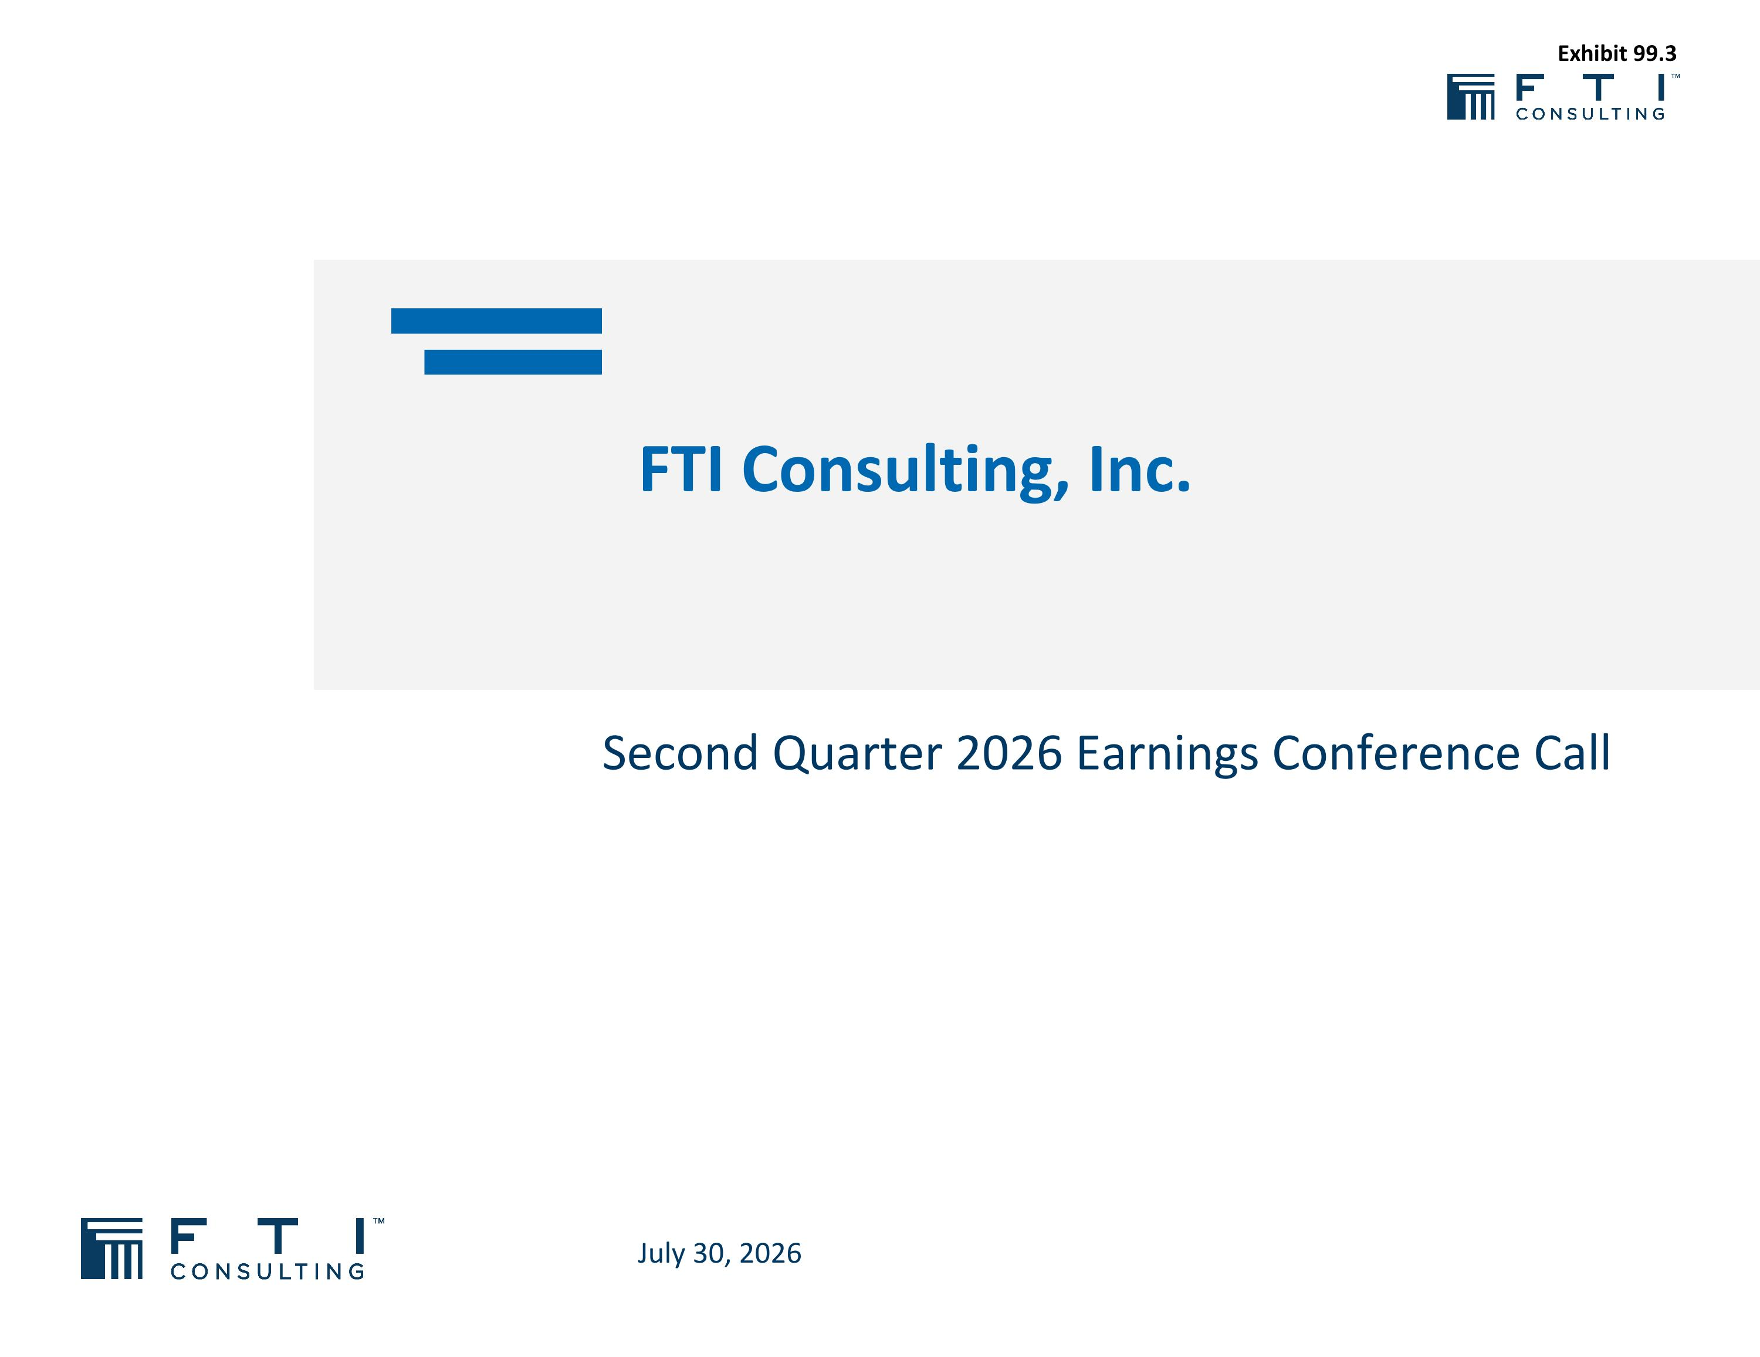
Second Quarter 2026 Earnings Conference Call FTI Consulting, Inc. July 30, 2026 Exhibit 99.3

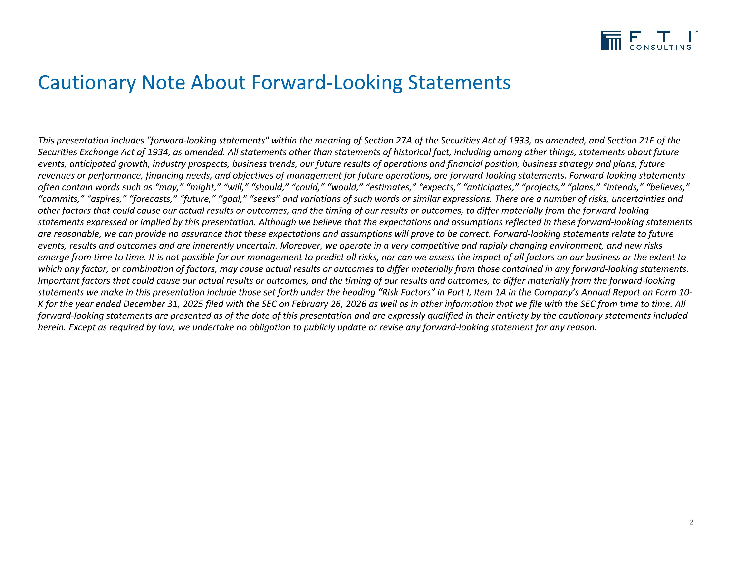
Cautionary Note About Forward-Looking Statements This presentation includes "forward-looking statements" within the meaning of Section 27A of the Securities Act of 1933, as amended, and Section 21E of the Securities Exchange Act of 1934, as amended. All statements other than statements of historical fact, including among other things, statements about future events, anticipated growth, industry prospects, business trends, our future results of operations and financial position, business strategy and plans, future revenues or performance, financing needs, and objectives of management for future operations, are forward-looking statements. Forward-looking statements often contain words such as “may,” “might,” “will,” “should,” “could,” “would,” “estimates,” “expects,” “anticipates,” “projects,” “plans,” “intends,” “believes,” “commits,” “aspires,” “forecasts,” “future,” “goal,” “seeks” and variations of such words or similar expressions. There are a number of risks, uncertainties and other factors that could cause our actual results or outcomes, and the timing of our results or outcomes, to differ materially from the forward-looking statements expressed or implied by this presentation. Although we believe that the expectations and assumptions reflected in these forward-looking statements are reasonable, we can provide no assurance that these expectations and assumptions will prove to be correct. Forward-looking statements relate to future events, results and outcomes and are inherently uncertain. Moreover, we operate in a very competitive and rapidly changing environment, and new risks emerge from time to time. It is not possible for our management to predict all risks, nor can we assess the impact of all factors on our business or the extent to which any factor, or combination of factors, may cause actual results or outcomes to differ materially from those contained in any forward-looking statements. Important factors that could cause our actual results or outcomes, and the timing of our results and outcomes, to differ materially from the forward-looking statements we make in this presentation include those set forth under the heading “Risk Factors” in Part I, Item 1A in the Company’s Annual Report on Form 10-K for the year ended December 31, 2025 filed with the SEC on February 26, 2026 as well as in other information that we file with the SEC from time to time. All forward-looking statements are presented as of the date of this presentation and are expressly qualified in their entirety by the cautionary statements included herein. Except as required by law, we undertake no obligation to publicly update or revise any forward-looking statement for any reason. 2

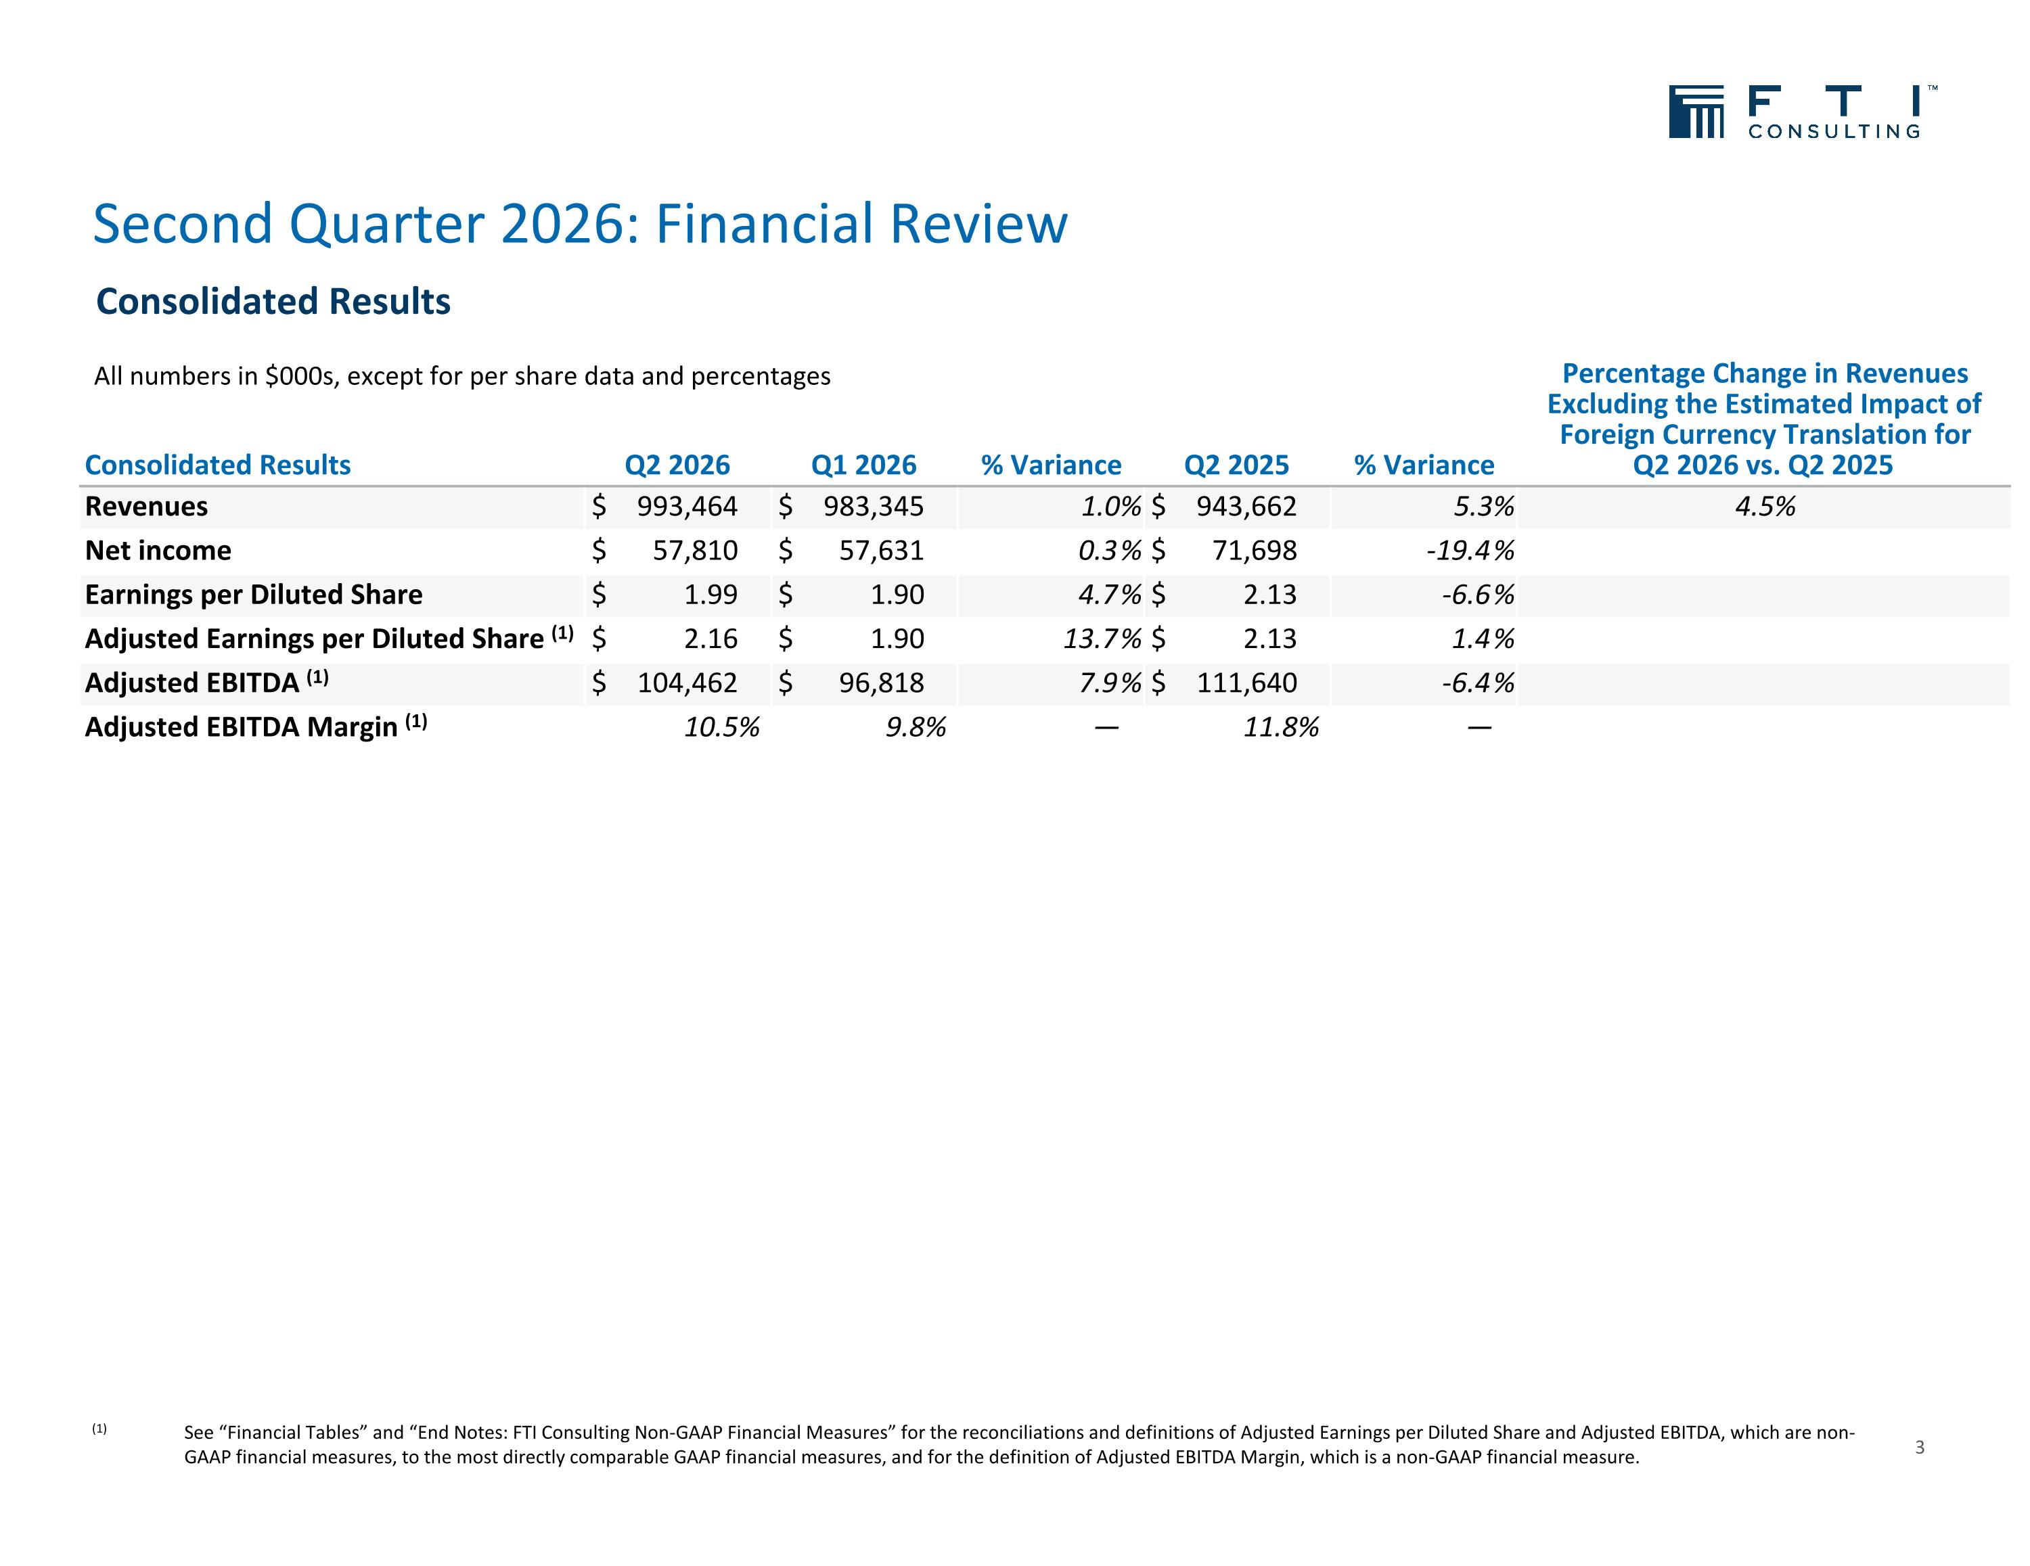
Second Quarter 2026: Financial Review 3 (1) See “Financial Tables” and “End Notes: FTI Consulting Non-GAAP Financial Measures” for the reconciliations and definitions of Adjusted Earnings per Diluted Share and Adjusted EBITDA, which are non-GAAP financial measures, to the most directly comparable GAAP financial measures, and for the definition of Adjusted EBITDA Margin, which is a non-GAAP financial measure. Consolidated Results Q2 2026 Q1 2026 % Variance Q2 2025 % Variance Percentage Change in Revenues Excluding the Estimated Impact of Foreign Currency Translation for Q2 2026 vs. Q2 2025 Revenues $ 993,464 $ 983,345 1.0% $ 943,662 5.3% 4.5% Net income $ 57,810 $ 57,631 0.3 % $ 71,698 -19.4 % Earnings per Diluted Share $ 1.99 $ 1.90 4.7 % $ 2.13 -6.6 % Adjusted Earnings per Diluted Share (1) $ 2.16 $ 1.90 13.7 % $ 2.13 1.4 % Adjusted EBITDA (1) $ 104,462 $ 96,818 7.9 % $ 111,640 -6.4 % Adjusted EBITDA Margin (1) 10.5% 9.8% — 11.8% — All numbers in $000s, except for per share data and percentages Consolidated Results

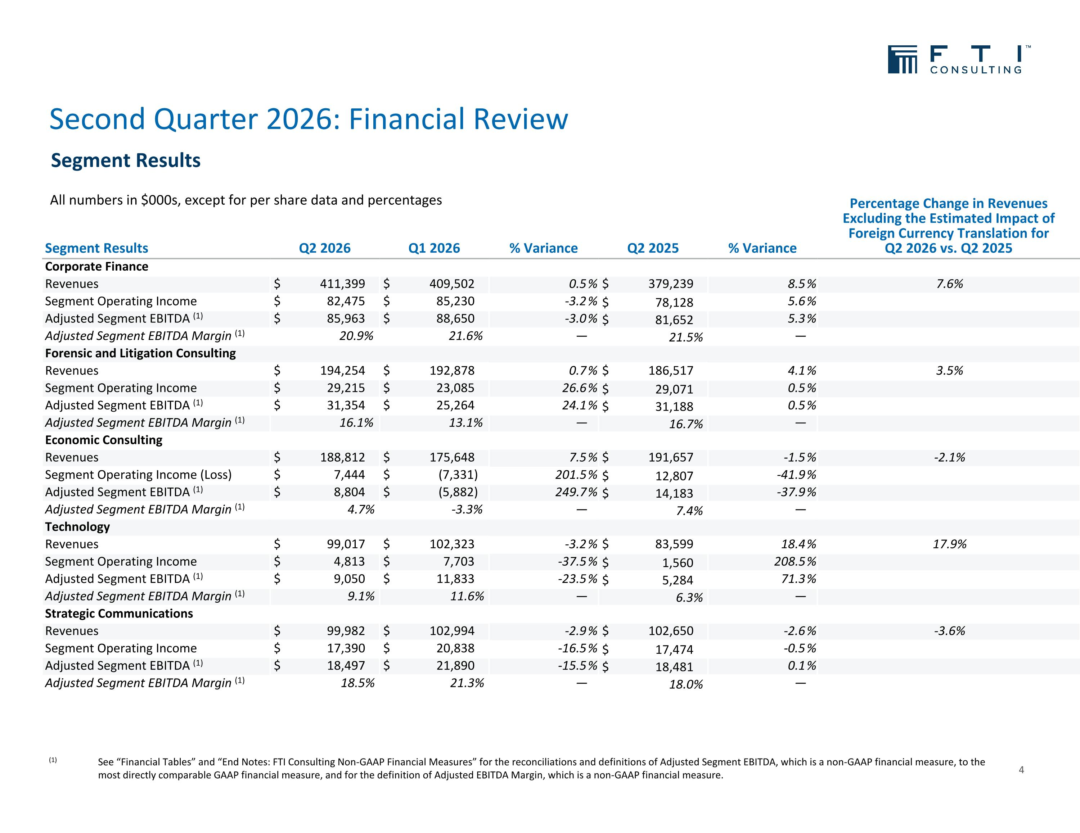
Second Quarter 2026: Financial Review 4 (1) See “Financial Tables” and “End Notes: FTI Consulting Non-GAAP Financial Measures” for the reconciliations and definitions of Adjusted Segment EBITDA, which is a non-GAAP financial measure, to the most directly comparable GAAP financial measure, and for the definition of Adjusted EBITDA Margin, which is a non-GAAP financial measure. Segment Results Q2 2026 Q1 2026 % Variance Q2 2025 % Variance Percentage Change in Revenues Excluding the Estimated Impact of Foreign Currency Translation for Q2 2026 vs. Q2 2025 Corporate Finance Revenues $ 411,399 $ 409,502 0.5 % $ 379,239 8.5 % 7.6% Segment Operating Income $ 82,475 $ 85,230 -3.2 % $ 78,128 5.6 % Adjusted Segment EBITDA (1) $ 85,963 $ 88,650 -3.0 % $ 81,652 5.3 % Adjusted Segment EBITDA Margin (1) 20.9% 21.6% — 21.5% — Forensic and Litigation Consulting Revenues $ 194,254 $ 192,878 0.7 % $ 186,517 4.1 % 3.5% Segment Operating Income $ 29,215 $ 23,085 26.6 % $ 29,071 0.5 % Adjusted Segment EBITDA (1) $ 31,354 $ 25,264 24.1 % $ 31,188 0.5 % Adjusted Segment EBITDA Margin (1) 16.1% 13.1% — 16.7% — Economic Consulting Revenues $ 188,812 $ 175,648 7.5 % $ 191,657 -1.5 % -2.1% Segment Operating Income (Loss) $ 7,444 $ (7,331) 201.5 % $ 12,807 -41.9 % Adjusted Segment EBITDA (1) $ 8,804 $ (5,882) 249.7 % $ 14,183 -37.9 % Adjusted Segment EBITDA Margin (1) 4.7% -3.3% — 7.4% — Technology Revenues $ 99,017 $ 102,323 -3.2 % $ 83,599 18.4 % 17.9% Segment Operating Income $ 4,813 $ 7,703 -37.5 % $ 1,560 208.5 % Adjusted Segment EBITDA (1) $ 9,050 $ 11,833 -23.5 % $ 5,284 71.3 % Adjusted Segment EBITDA Margin (1) 9.1% 11.6% — 6.3% — Strategic Communications Revenues $ 99,982 $ 102,994 -2.9 % $ 102,650 -2.6 % -3.6% Segment Operating Income $ 17,390 $ 20,838 -16.5 % $ 17,474 -0.5 % Adjusted Segment EBITDA (1) $ 18,497 $ 21,890 -15.5 % $ 18,481 0.1 % Adjusted Segment EBITDA Margin (1) 18.5% 21.3% — 18.0% — All numbers in $000s, except for per share data and percentages Segment Results

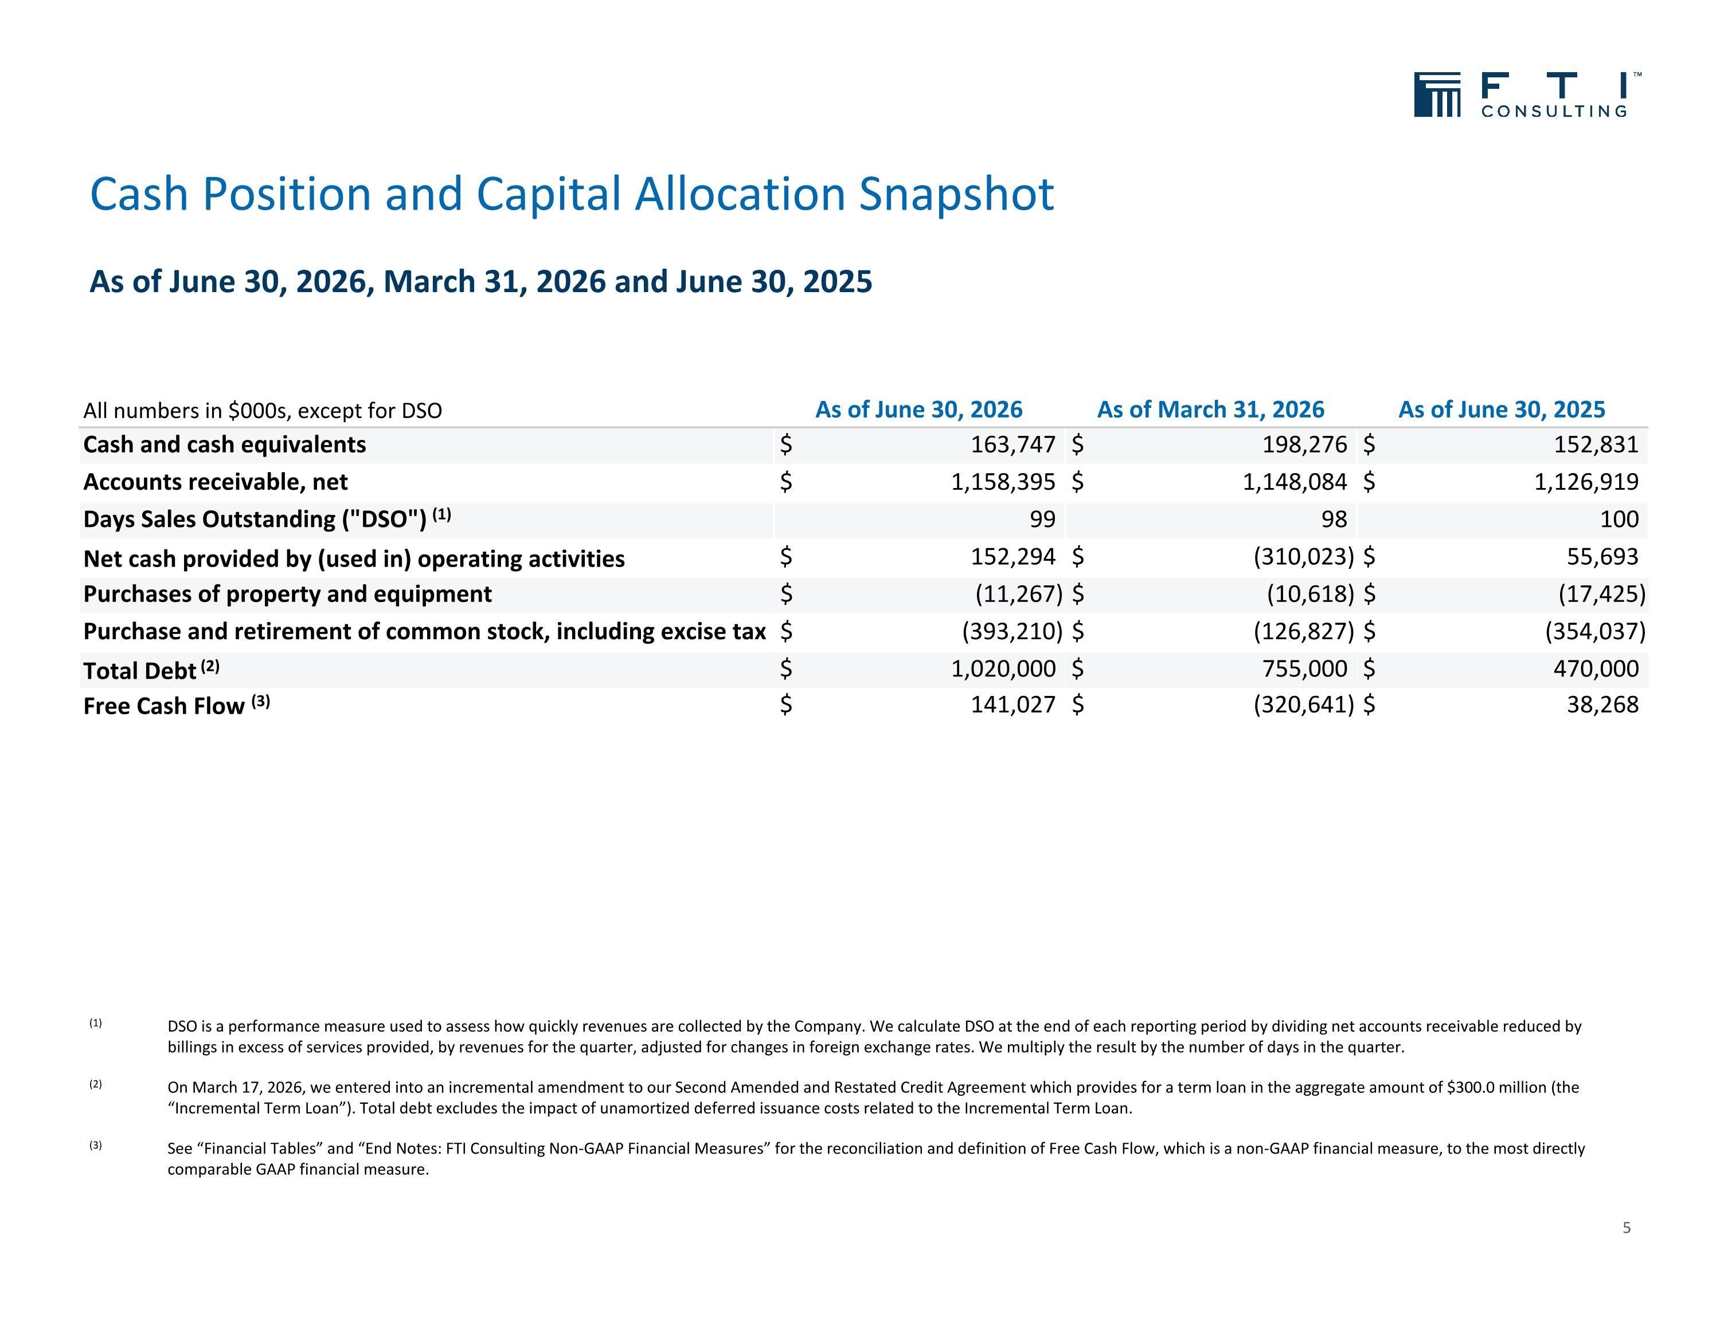
Cash Position and Capital Allocation Snapshot As of June 30, 2026, March 31, 2026 and June 30, 2025 5 (1) DSO is a performance measure used to assess how quickly revenues are collected by the Company. We calculate DSO at the end of each reporting period by dividing net accounts receivable reduced by billings in excess of services provided, by revenues for the quarter, adjusted for changes in foreign exchange rates. We multiply the result by the number of days in the quarter. (2) On March 17, 2026, we entered into an incremental amendment to our Second Amended and Restated Credit Agreement which provides for a term loan in the aggregate amount of $300.0 million (the “Incremental Term Loan”). Total debt excludes the impact of unamortized deferred issuance costs related to the Incremental Term Loan. (3) See “Financial Tables” and “End Notes: FTI Consulting Non-GAAP Financial Measures” for the reconciliation and definition of Free Cash Flow, which is a non-GAAP financial measure, to the most directly comparable GAAP financial measure. All numbers in $000s, except for DSO As of June 30, 2026 As of March 31, 2026 As of June 30, 2025 Cash and cash equivalents $ 163,747 $ 198,276 $ 152,831 Accounts receivable, net $ 1,158,395 $ 1,148,084 $ 1,126,919 Days Sales Outstanding ("DSO") (1) 99 98 100 Net cash provided by (used in) operating activities $ 152,294 $ (310,023) $ 55,693 Purchases of property and equipment $ (11,267) $ (10,618) $ (17,425) Purchase and retirement of common stock, including excise tax $ (393,210) $ (126,827) $ (354,037) Total Debt (2) $ 1,020,000 $ 755,000 $ 470,000 Free Cash Flow (3) $ 141,027 $ (320,641) $ 38,268

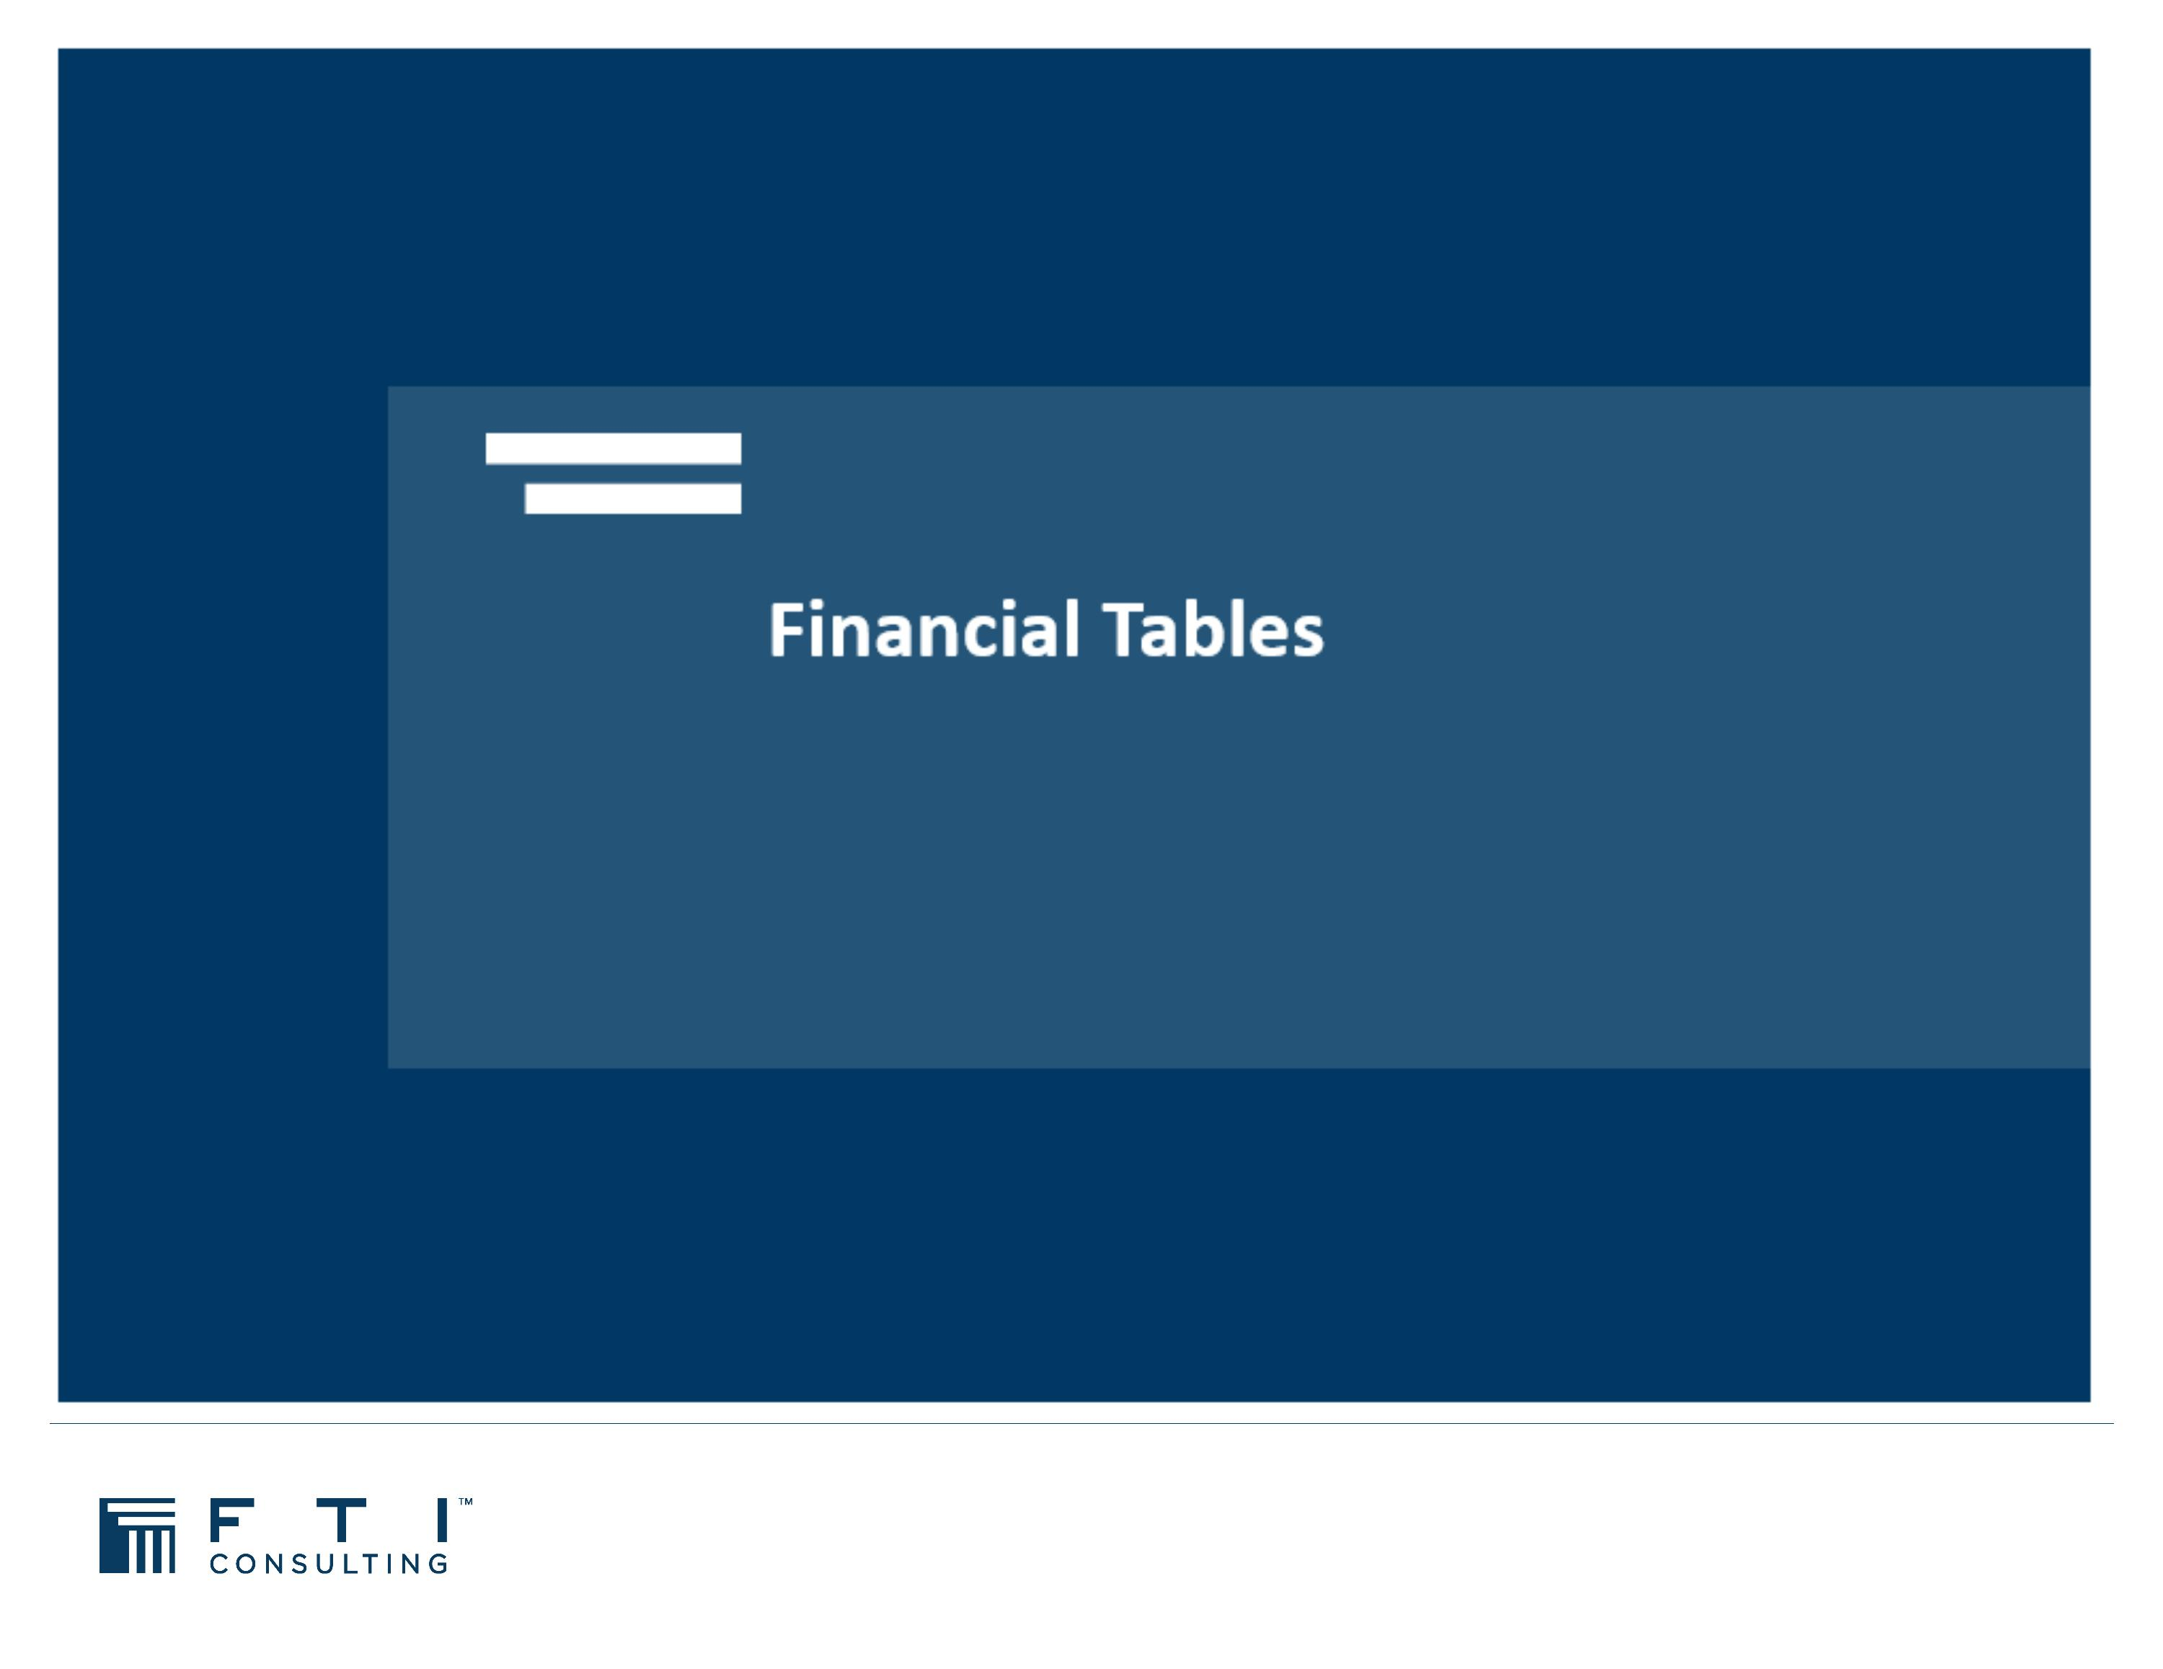

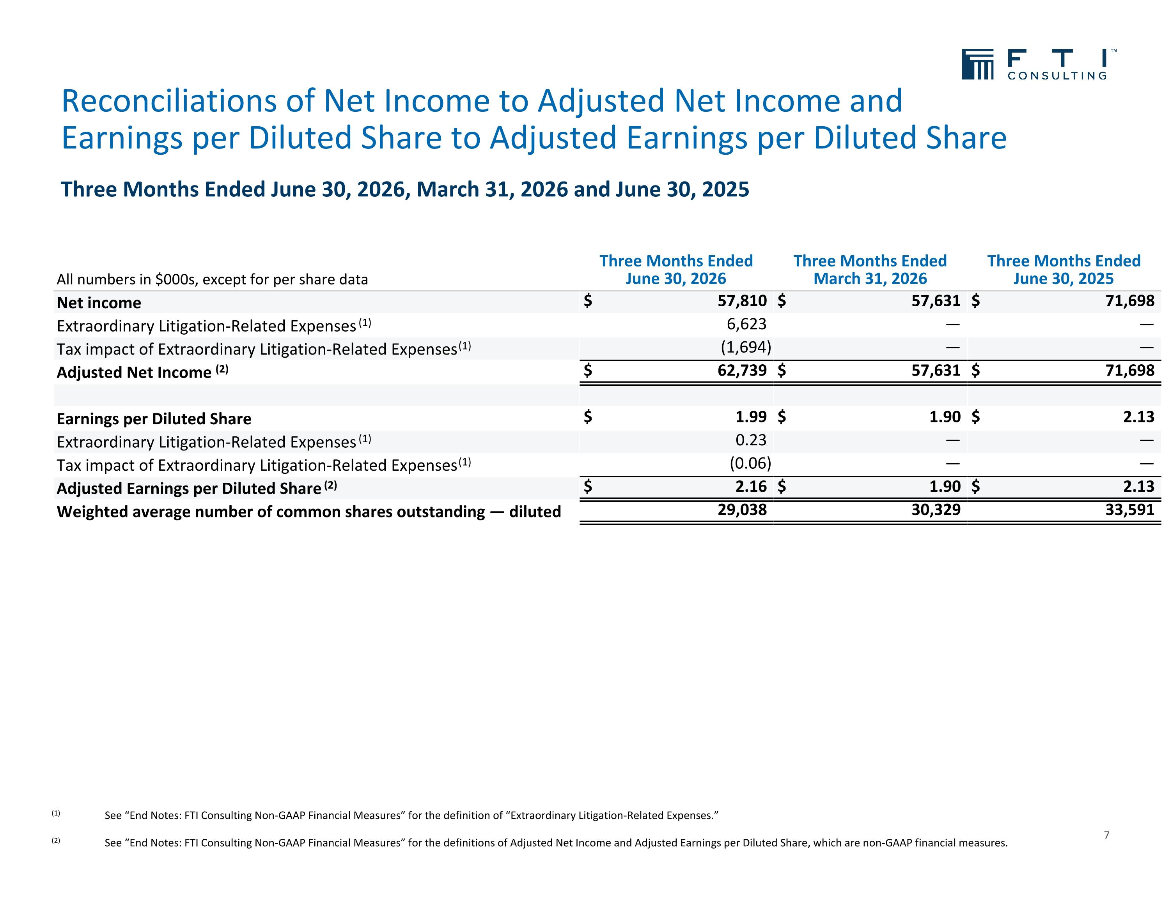
Three Months Ended June 30, 2026, March 31, 2026 and June 30, 2025 Reconciliations of Net Income to Adjusted Net Income and Earnings per Diluted Share to Adjusted Earnings per Diluted Share 7 (1) See “End Notes: FTI Consulting Non-GAAP Financial Measures” for the definition of “Extraordinary Litigation-Related Expenses.” (2) See “End Notes: FTI Consulting Non-GAAP Financial Measures” for the definitions of Adjusted Net Income and Adjusted Earnings per Diluted Share, which are non-GAAP financial measures. All numbers in $000s, except for per share data Three Months Ended June 30, 2026 Three Months Ended March 31, 2026 Three Months Ended June 30, 2025 Net income $ 57,810 $ 57,631 $ 71,698 Extraordinary Litigation-Related Expenses (1) 6,623 — — Tax impact of Extraordinary Litigation-Related Expenses (1) (1,694) — — Adjusted Net Income (2) $ 62,739 $ 57,631 $ 71,698 Earnings per Diluted Share $ 1.99 $ 1.90 $ 2.13 Extraordinary Litigation-Related Expenses (1) 0.23 — — Tax impact of Extraordinary Litigation-Related Expenses (1) (0.06) — — Adjusted Earnings per Diluted Share (2) $ 2.16 $ 1.90 $ 2.13 Weighted average number of common shares outstanding — diluted 29,038 30,329 33,591

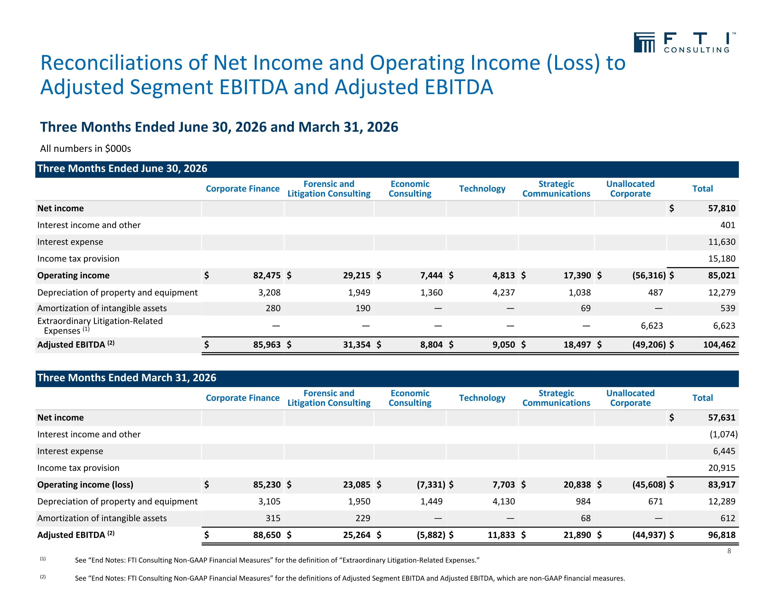
Three Months Ended June 30, 2026 and March 31, 2026 Reconciliations of Net Income and Operating Income (Loss) to Adjusted Segment EBITDA and Adjusted EBITDA All numbers in $000s (1) See “End Notes: FTI Consulting Non-GAAP Financial Measures” for the definition of “Extraordinary Litigation-Related Expenses.” (2) See “End Notes: FTI Consulting Non-GAAP Financial Measures” for the definitions of Adjusted Segment EBITDA and Adjusted EBITDA, which are non-GAAP financial measures. Three Months Ended June 30, 2026 Corporate Finance Forensic and Litigation Consulting Economic Consulting Technology Strategic Communications Unallocated Corporate Total Net income $ 57,810 Interest income and other 401 Interest expense 11,630 Income tax provision 15,180 Operating income $ 82,475 $ 29,215 $ 7,444 $ 4,813 $ 17,390 $ (56,316) $ 85,021 Depreciation of property and equipment 3,208 1,949 1,360 4,237 1,038 487 12,279 Amortization of intangible assets 280 190 — — 69 — 539 Extraordinary Litigation-Related Expenses (1) — — — — — 6,623 6,623 Adjusted EBITDA (2) $ 85,963 $ 31,354 $ 8,804 $ 9,050 $ 18,497 $ (49,206) $ 104,462 Three Months Ended March 31, 2026 Corporate Finance Forensic and Litigation Consulting Economic Consulting Technology Strategic Communications Unallocated Corporate Total Net income $ 57,631 Interest income and other (1,074) Interest expense 6,445 Income tax provision 20,915 Operating income (loss) $ 85,230 $ 23,085 $ (7,331) $ 7,703 $ 20,838 $ (45,608) $ 83,917 Depreciation of property and equipment 3,105 1,950 1,449 4,130 984 671 12,289 Amortization of intangible assets 315 229 — — 68 — 612 Adjusted EBITDA (2) $ 88,650 $ 25,264 $ (5,882) $ 11,833 $ 21,890 $ (44,937) $ 96,818 8

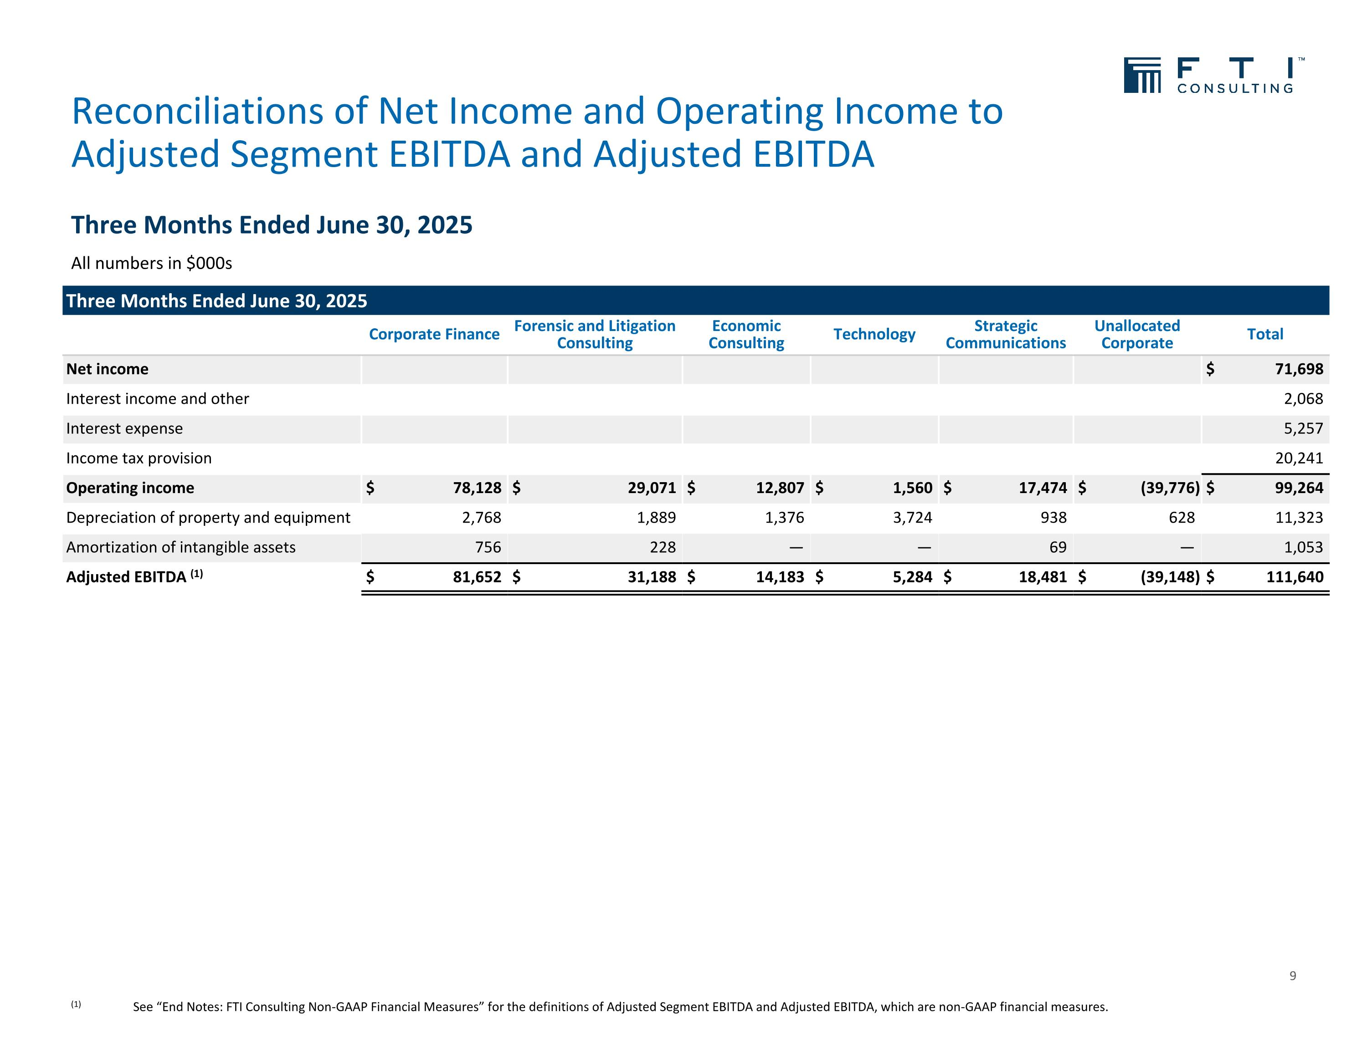
Three Months Ended June 30, 2025 Reconciliations of Net Income and Operating Income to Adjusted Segment EBITDA and Adjusted EBITDA 9 All numbers in $000s Three Months Ended June 30, 2025 Corporate Finance Forensic and Litigation Consulting Economic Consulting Technology Strategic Communications Unallocated Corporate Total Net income $ 71,698 Interest income and other 2,068 Interest expense 5,257 Income tax provision 20,241 Operating income $ 78,128 $ 29,071 $ 12,807 $ 1,560 $ 17,474 $ (39,776) $ 99,264 Depreciation of property and equipment 2,768 1,889 1,376 3,724 938 628 11,323 Amortization of intangible assets 756 228 — — 69 — 1,053 Adjusted EBITDA (1) $ 81,652 $ 31,188 $ 14,183 $ 5,284 $ 18,481 $ (39,148) $ 111,640 (1) See “End Notes: FTI Consulting Non-GAAP Financial Measures” for the definitions of Adjusted Segment EBITDA and Adjusted EBITDA, which are non-GAAP financial measures.

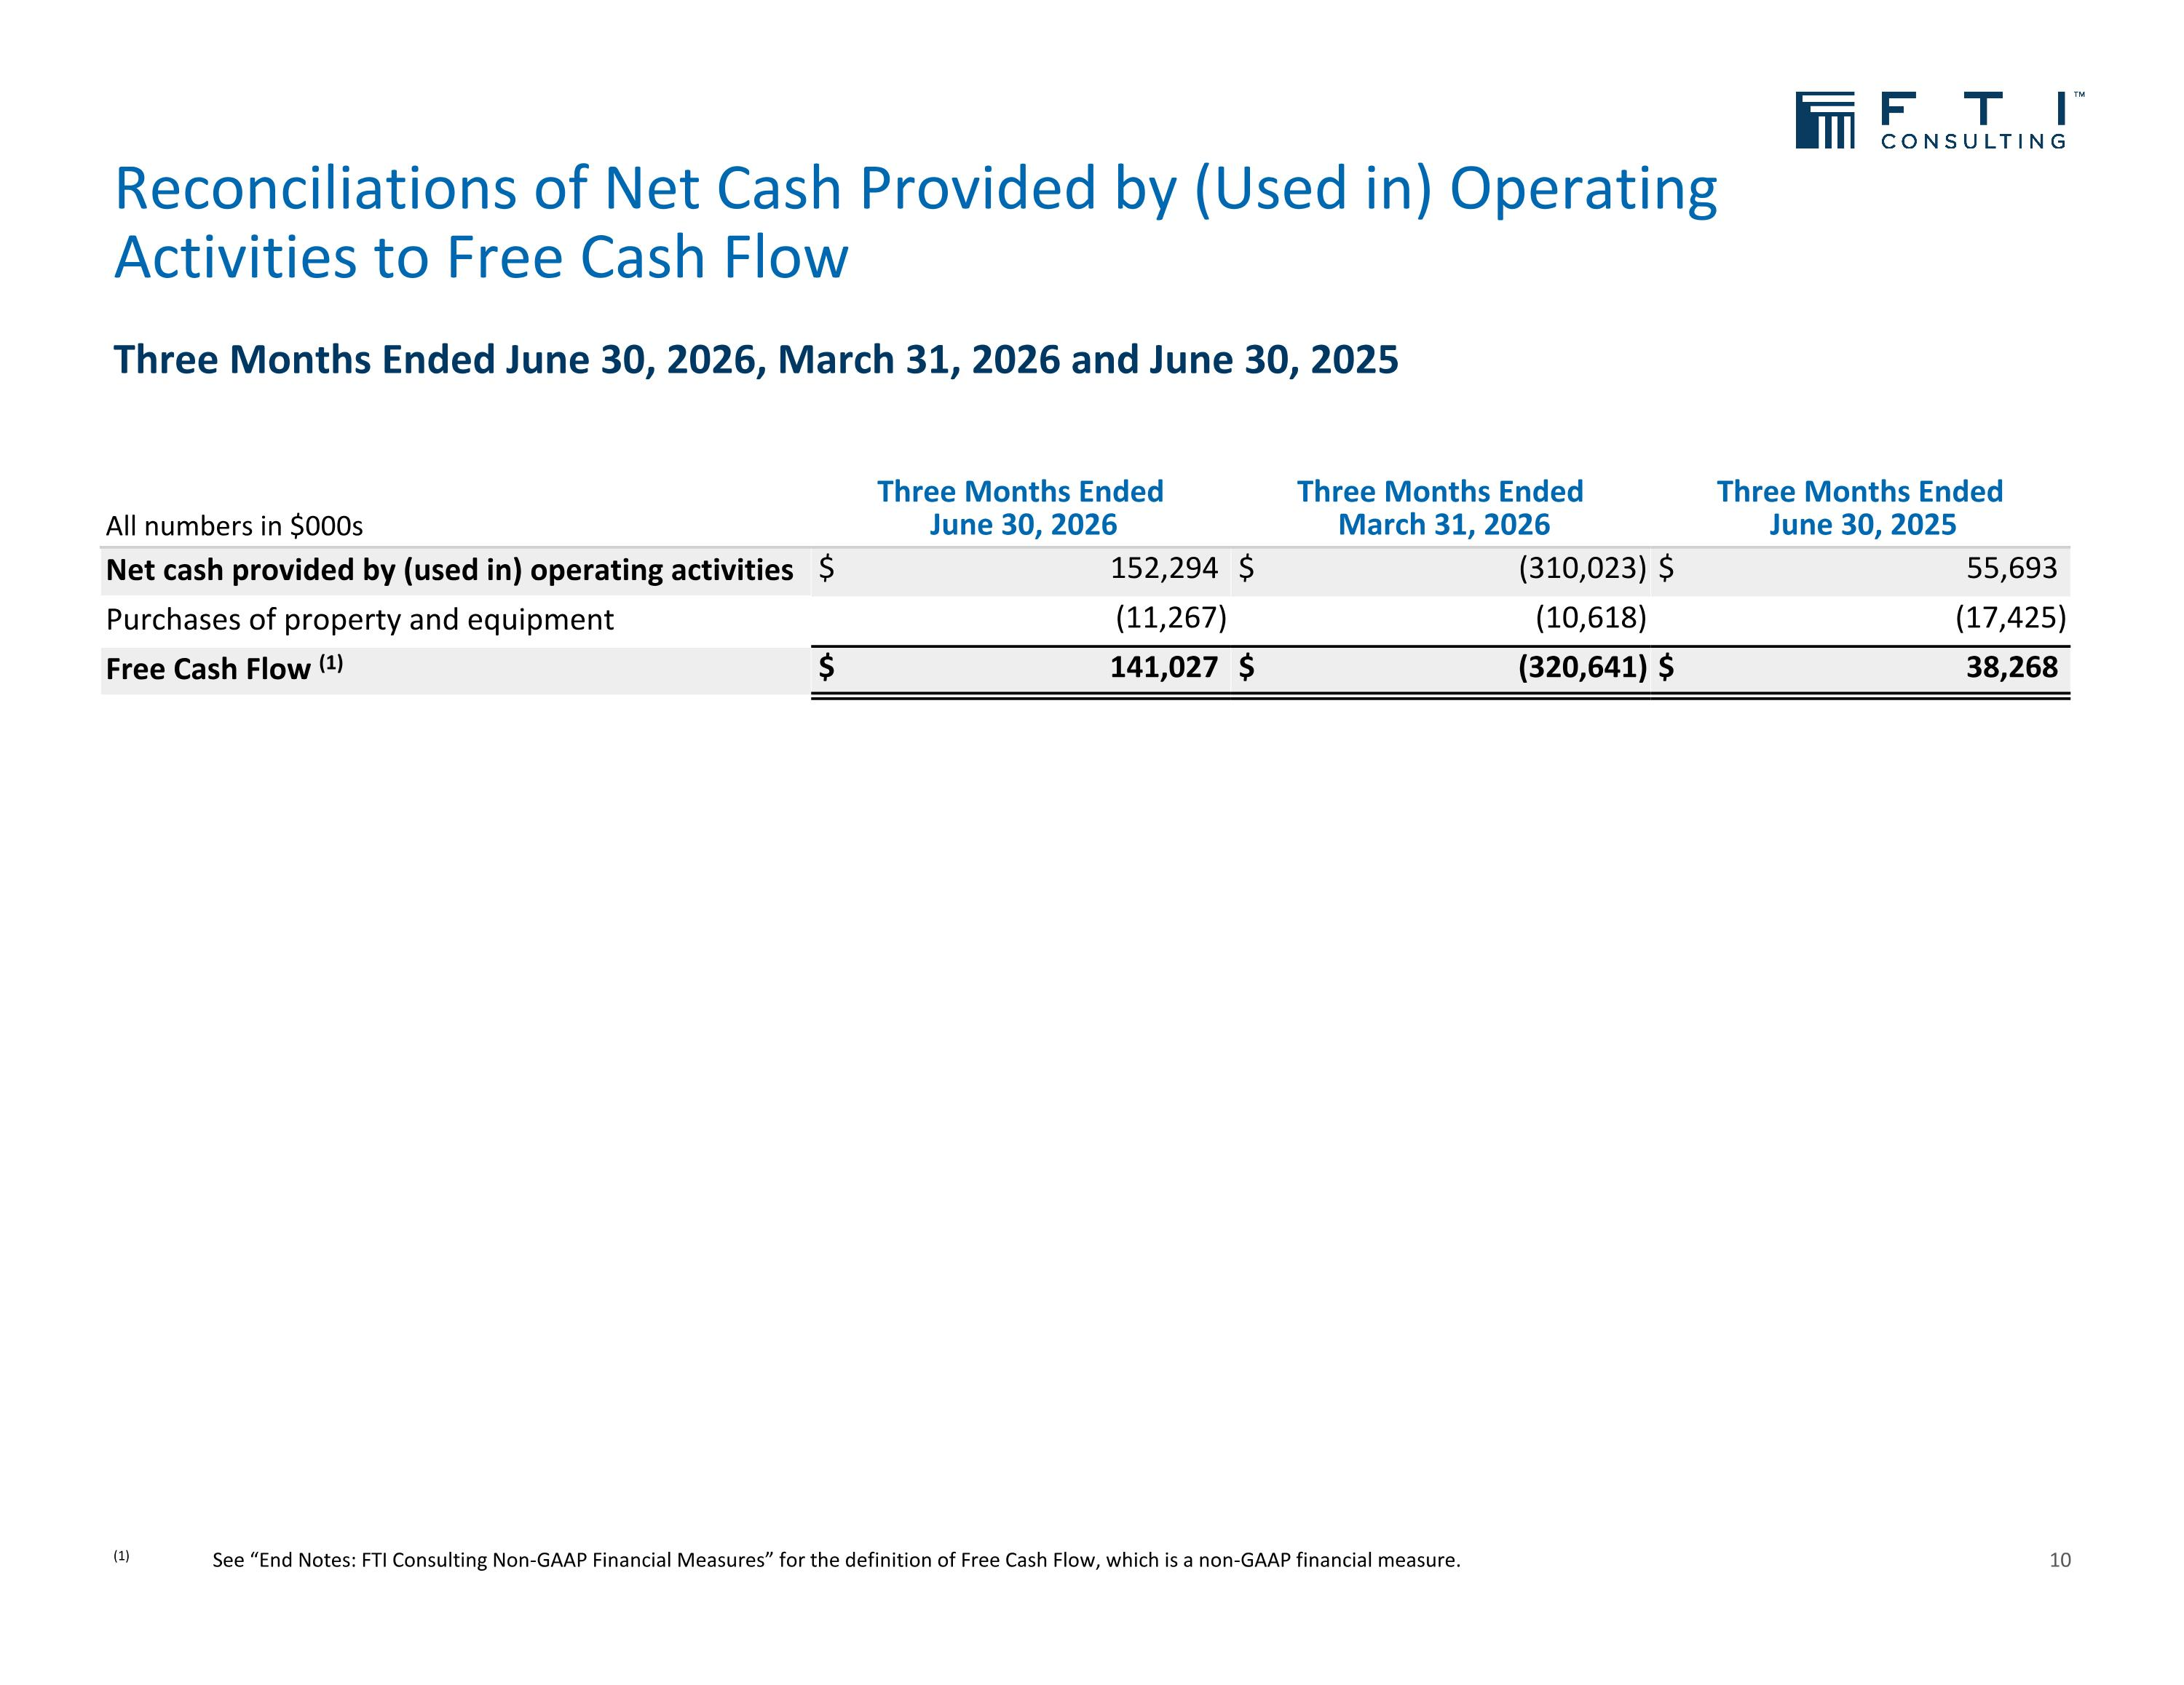
Three Months Ended June 30, 2026, March 31, 2026 and June 30, 2025 Reconciliations of Net Cash Provided by (Used in) Operating Activities to Free Cash Flow 10 (1) See “End Notes: FTI Consulting Non-GAAP Financial Measures” for the definition of Free Cash Flow, which is a non-GAAP financial measure. All numbers in $000s Three Months Ended June 30, 2026 Three Months Ended March 31, 2026 Three Months Ended June 30, 2025 Net cash provided by (used in) operating activities $ 152,294 $ (310,023) $ 55,693 Purchases of property and equipment (11,267) (10,618) (17,425) Free Cash Flow (1) $ 141,027 $ (320,641) $ 38,268

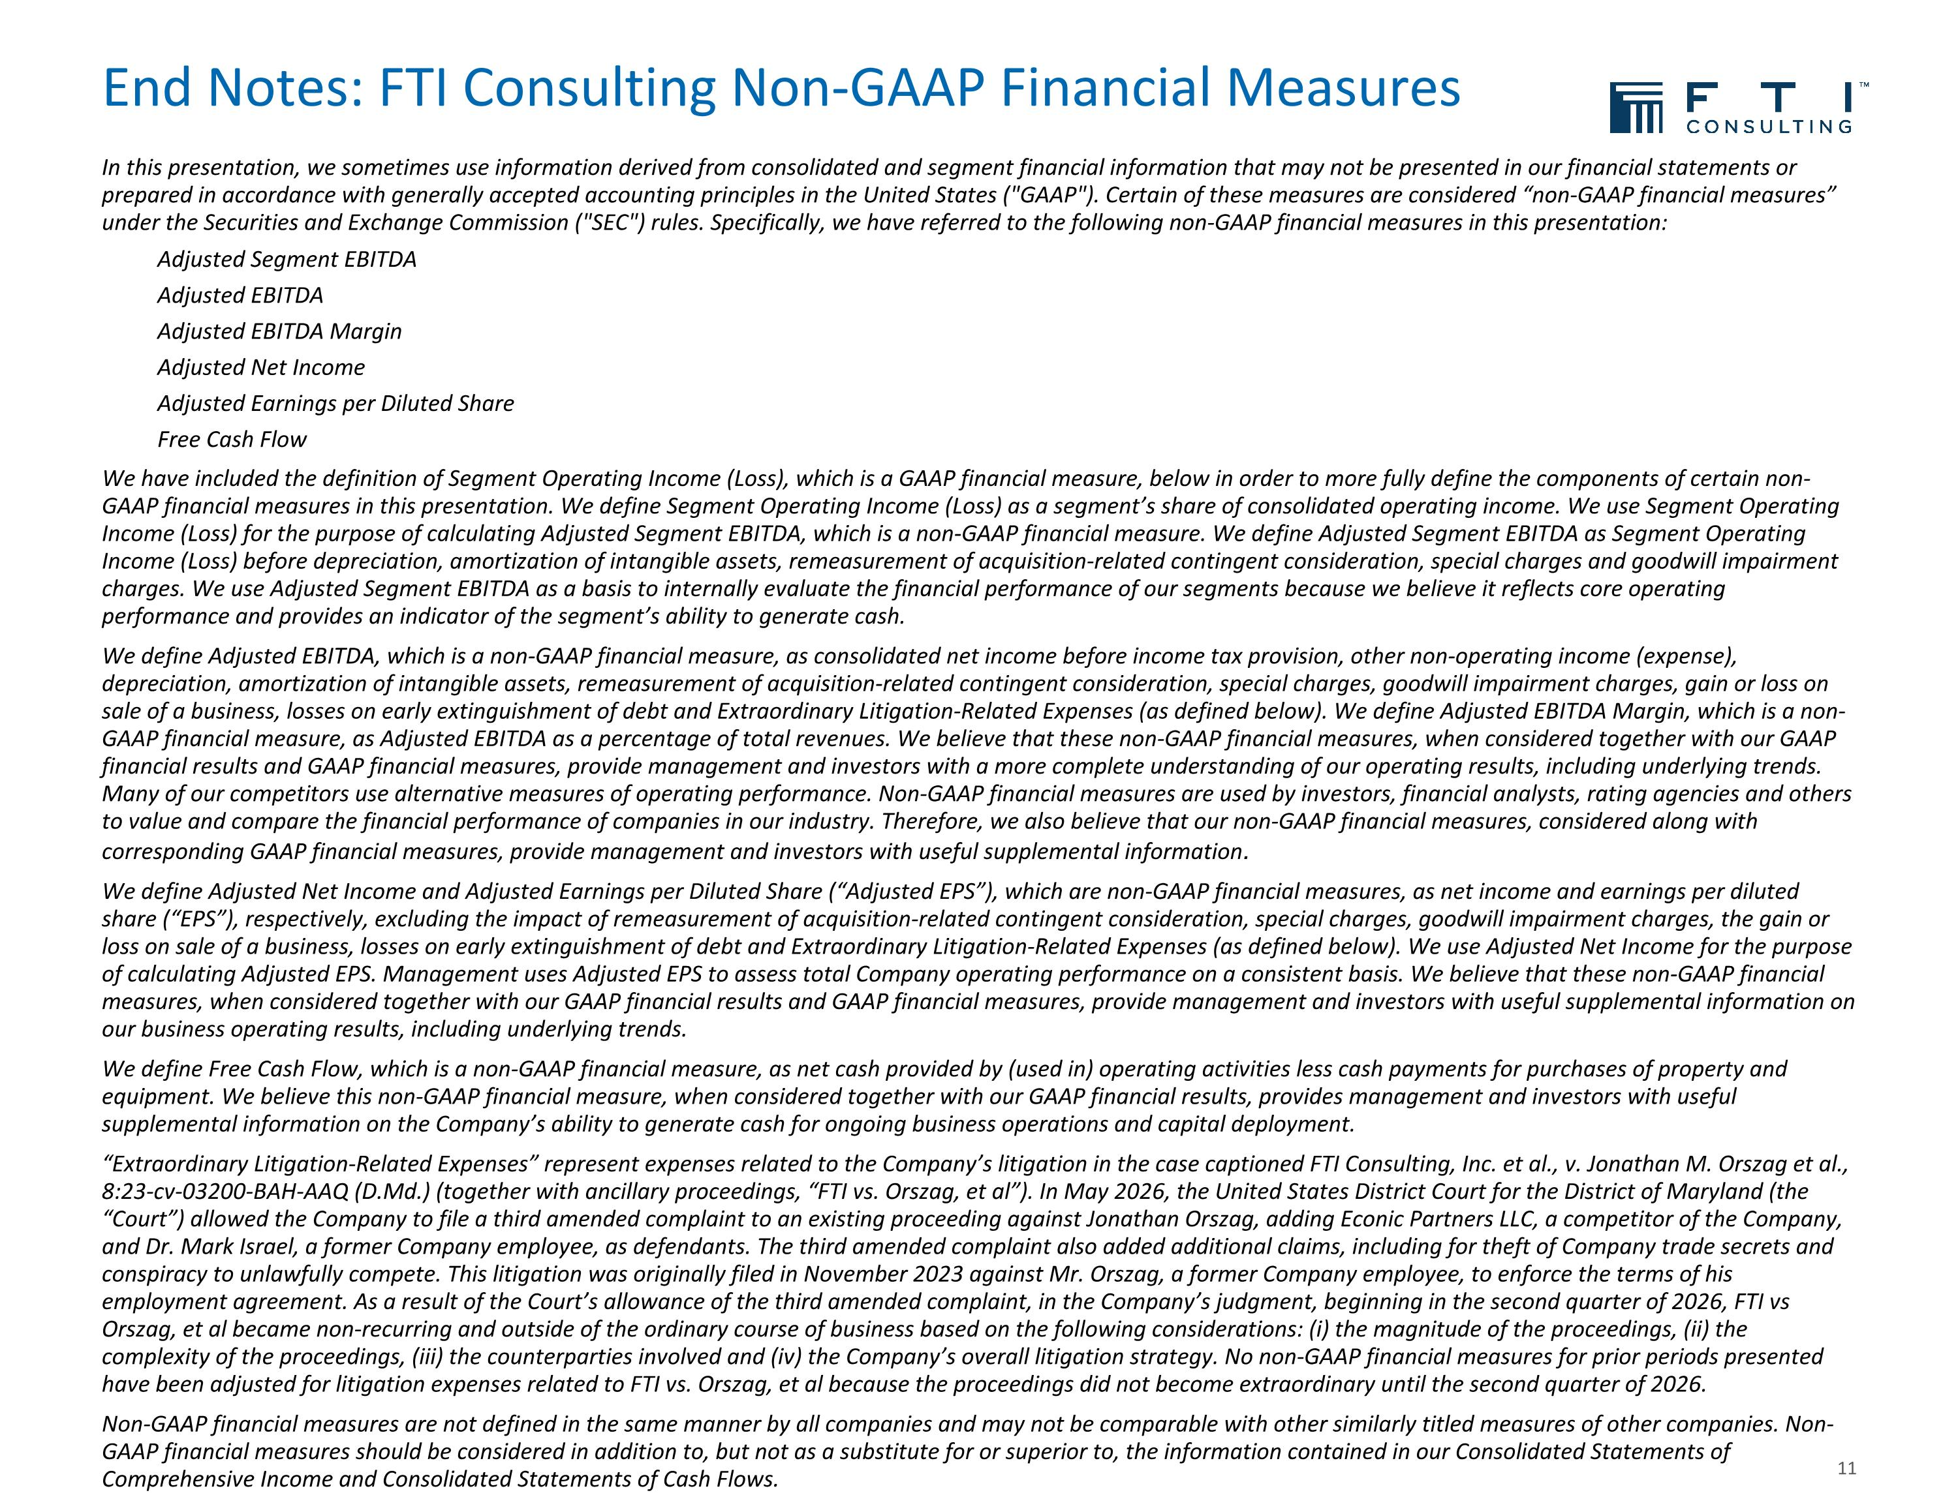
End Notes: FTI Consulting Non-GAAP Financial Measures In this presentation, we sometimes use information derived from consolidated and segment financial information that may not be presented in our financial statements or prepared in accordance with generally accepted accounting principles in the United States ("GAAP"). Certain of these measures are considered “non-GAAP financial measures” under the Securities and Exchange Commission ("SEC") rules. Specifically, we have referred to the following non-GAAP financial measures in this presentation: Adjusted Segment EBITDA Adjusted EBITDA Adjusted EBITDA Margin Adjusted Net Income Adjusted Earnings per Diluted Share Free Cash Flow We have included the definition of Segment Operating Income (Loss), which is a GAAP financial measure, below in order to more fully define the components of certain non-GAAP financial measures in this presentation. We define Segment Operating Income (Loss) as a segment’s share of consolidated operating income. We use Segment Operating Income (Loss) for the purpose of calculating Adjusted Segment EBITDA, which is a non-GAAP financial measure. We define Adjusted Segment EBITDA as Segment Operating Income (Loss) before depreciation, amortization of intangible assets, remeasurement of acquisition-related contingent consideration, special charges and goodwill impairment charges. We use Adjusted Segment EBITDA as a basis to internally evaluate the financial performance of our segments because we believe it reflects core operating performance and provides an indicator of the segment’s ability to generate cash. We define Adjusted EBITDA, which is a non-GAAP financial measure, as consolidated net income before income tax provision, other non-operating income (expense), depreciation, amortization of intangible assets, remeasurement of acquisition-related contingent consideration, special charges, goodwill impairment charges, gain or loss on sale of a business, losses on early extinguishment of debt and Extraordinary Litigation-Related Expenses (as defined below). We define Adjusted EBITDA Margin, which is a non-GAAP financial measure, as Adjusted EBITDA as a percentage of total revenues. We believe that these non-GAAP financial measures, when considered together with our GAAP financial results and GAAP financial measures, provide management and investors with a more complete understanding of our operating results, including underlying trends. Many of our competitors use alternative measures of operating performance. Non-GAAP financial measures are used by investors, financial analysts, rating agencies and others to value and compare the financial performance of companies in our industry. Therefore, we also believe that our non-GAAP financial measures, considered along with corresponding GAAP financial measures, provide management and investors with useful supplemental information. We define Adjusted Net Income and Adjusted Earnings per Diluted Share (“Adjusted EPS”), which are non-GAAP financial measures, as net income and earnings per diluted share (“EPS”), respectively, excluding the impact of remeasurement of acquisition-related contingent consideration, special charges, goodwill impairment charges, the gain or loss on sale of a business, losses on early extinguishment of debt and Extraordinary Litigation-Related Expenses (as defined below). We use Adjusted Net Income for the purpose of calculating Adjusted EPS. Management uses Adjusted EPS to assess total Company operating performance on a consistent basis. We believe that these non-GAAP financial measures, when considered together with our GAAP financial results and GAAP financial measures, provide management and investors with useful supplemental information on our business operating results, including underlying trends. We define Free Cash Flow, which is a non-GAAP financial measure, as net cash provided by (used in) operating activities less cash payments for purchases of property and equipment. We believe this non-GAAP financial measure, when considered together with our GAAP financial results, provides management and investors with useful supplemental information on the Company’s ability to generate cash for ongoing business operations and capital deployment. “Extraordinary Litigation-Related Expenses” represent expenses related to the Company’s litigation in the case captioned FTI Consulting, Inc. et al., v. Jonathan M. Orszag et al., 8:23-cv-03200-BAH-AAQ (D.Md.) (together with ancillary proceedings, “FTI vs. Orszag, et al”). In May 2026, the United States District Court for the District of Maryland (the “Court”) allowed the Company to file a third amended complaint to an existing proceeding against Jonathan Orszag, adding Econic Partners LLC, a competitor of the Company, and Dr. Mark Israel, a former Company employee, as defendants. The third amended complaint also added additional claims, including for theft of Company trade secrets and conspiracy to unlawfully compete. This litigation was originally filed in November 2023 against Mr. Orszag, a former Company employee, to enforce the terms of his employment agreement. As a result of the Court’s allowance of the third amended complaint, in the Company’s judgment, beginning in the second quarter of 2026, FTI vs Orszag, et al became non-recurring and outside of the ordinary course of business based on the following considerations: (i) the magnitude of the proceedings, (ii) the complexity of the proceedings, (iii) the counterparties involved and (iv) the Company’s overall litigation strategy. No non-GAAP financial measures for prior periods presented have been adjusted for litigation expenses related to FTI vs. Orszag, et al because the proceedings did not become extraordinary until the second quarter of 2026. Non-GAAP financial measures are not defined in the same manner by all companies and may not be comparable with other similarly titled measures of other companies. Non-GAAP financial measures should be considered in addition to, but not as a substitute for or superior to, the information contained in our Consolidated Statements of Comprehensive Income and Consolidated Statements of Cash Flows. 11

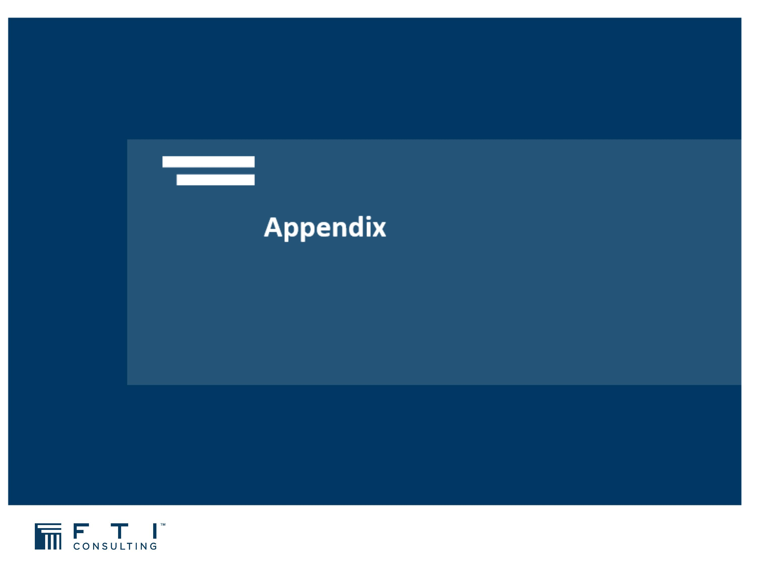

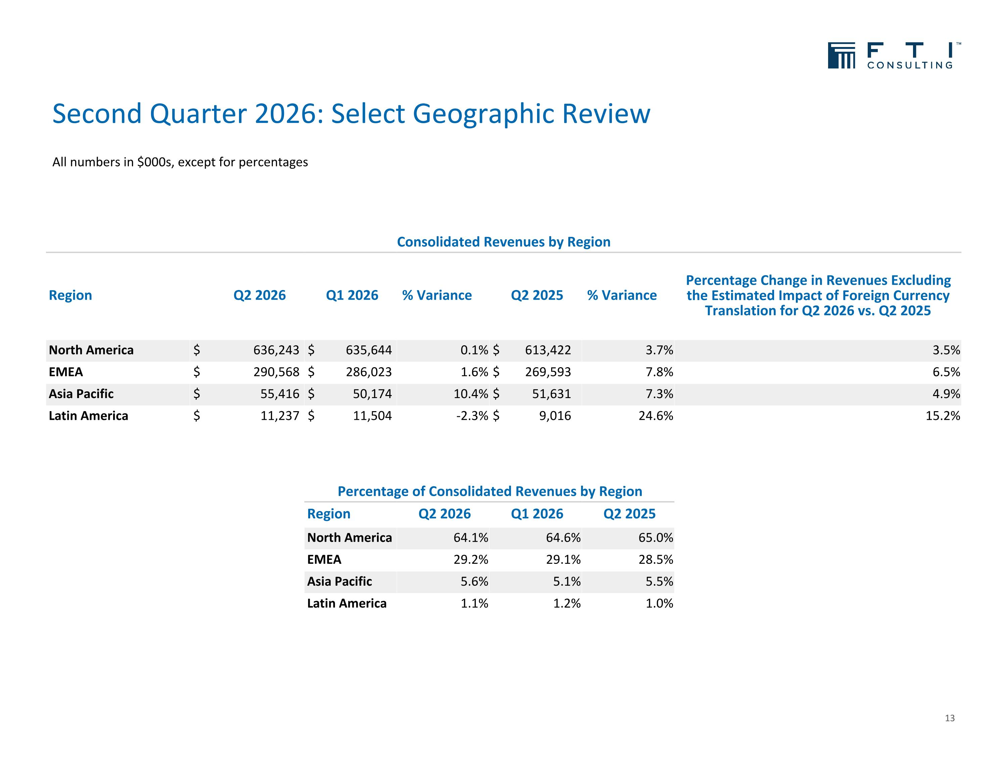
Second Quarter 2026: Select Geographic Review 13 Consolidated Revenues by Region Region Q2 2026 Q1 2026 % Variance Q2 2025 % Variance Percentage Change in Revenues Excluding the Estimated Impact of Foreign Currency Translation for Q2 2026 vs. Q2 2025 North America $ 636,243 $ 635,644 0.1% $ 613,422 3.7% 3.5% EMEA $ 290,568 $ 286,023 1.6% $ 269,593 7.8% 6.5% Asia Pacific $ 55,416 $ 50,174 10.4% $ 51,631 7.3% 4.9% Latin America $ 11,237 $ 11,504 -2.3% $ 9,016 24.6% 15.2% Percentage of Consolidated Revenues by Region Region Q2 2026 Q1 2026 Q2 2025 North America 64.1% 64.6% 65.0% EMEA 29.2% 29.1% 28.5% Asia Pacific 5.6% 5.1% 5.5% Latin America 1.1% 1.2% 1.0% All numbers in $000s, except for percentages

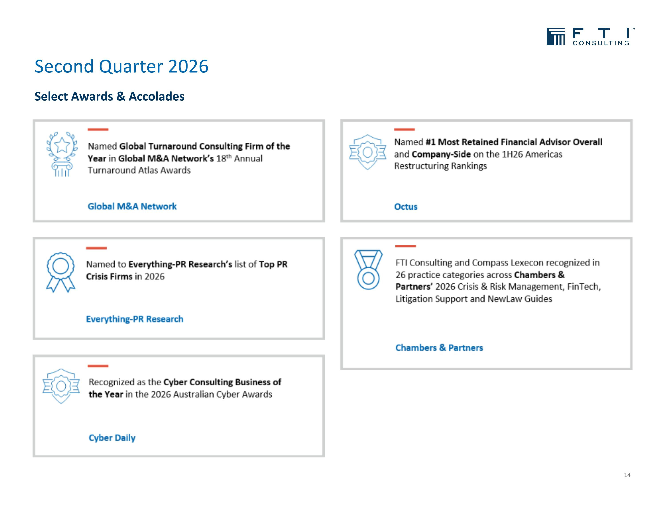
Second Quarter 2026 14 Select Awards & Accolades

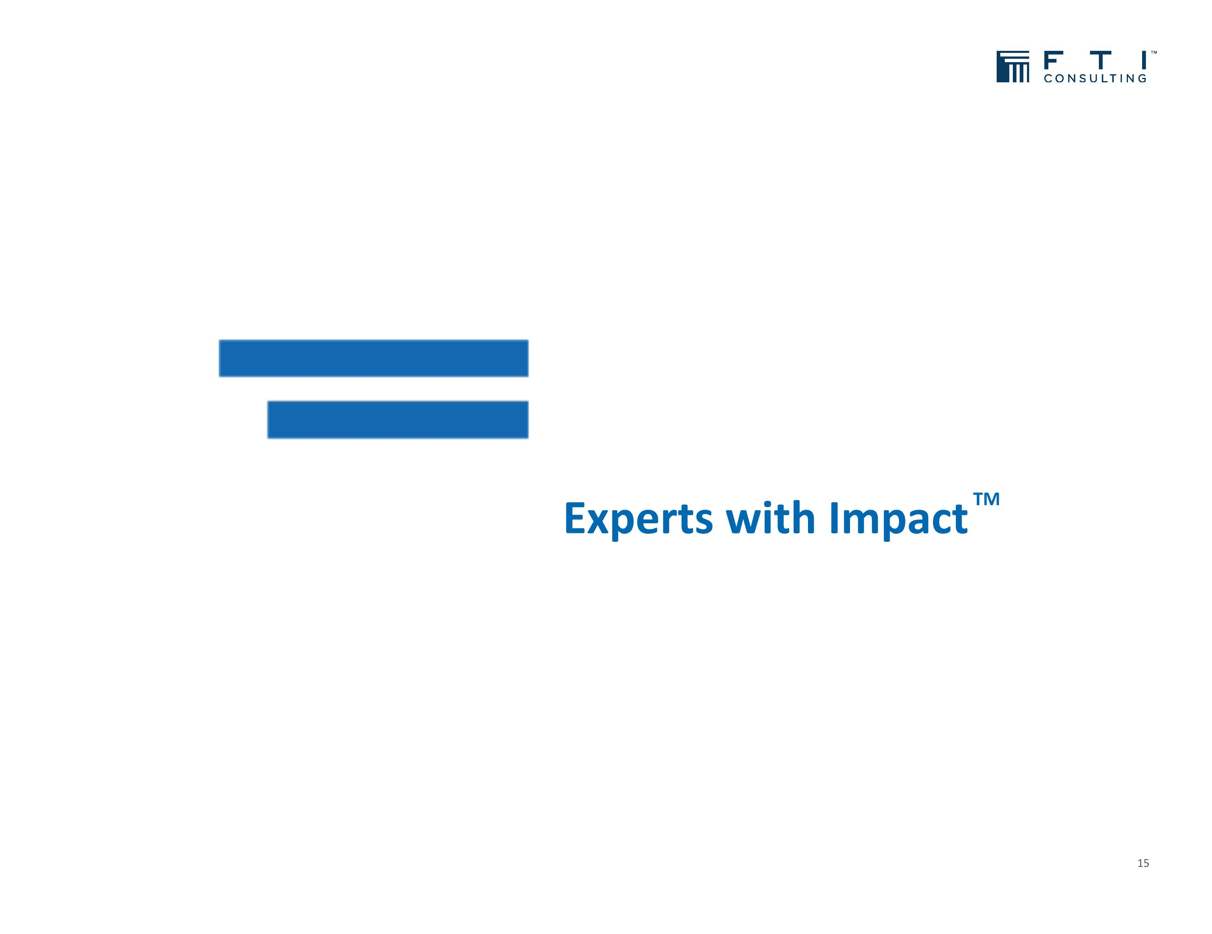
15 Experts with Impact TM

